GIT PRACTICE SCREENSHOTS

5523302_MALAVIKA RAJESH

**Practice 1**

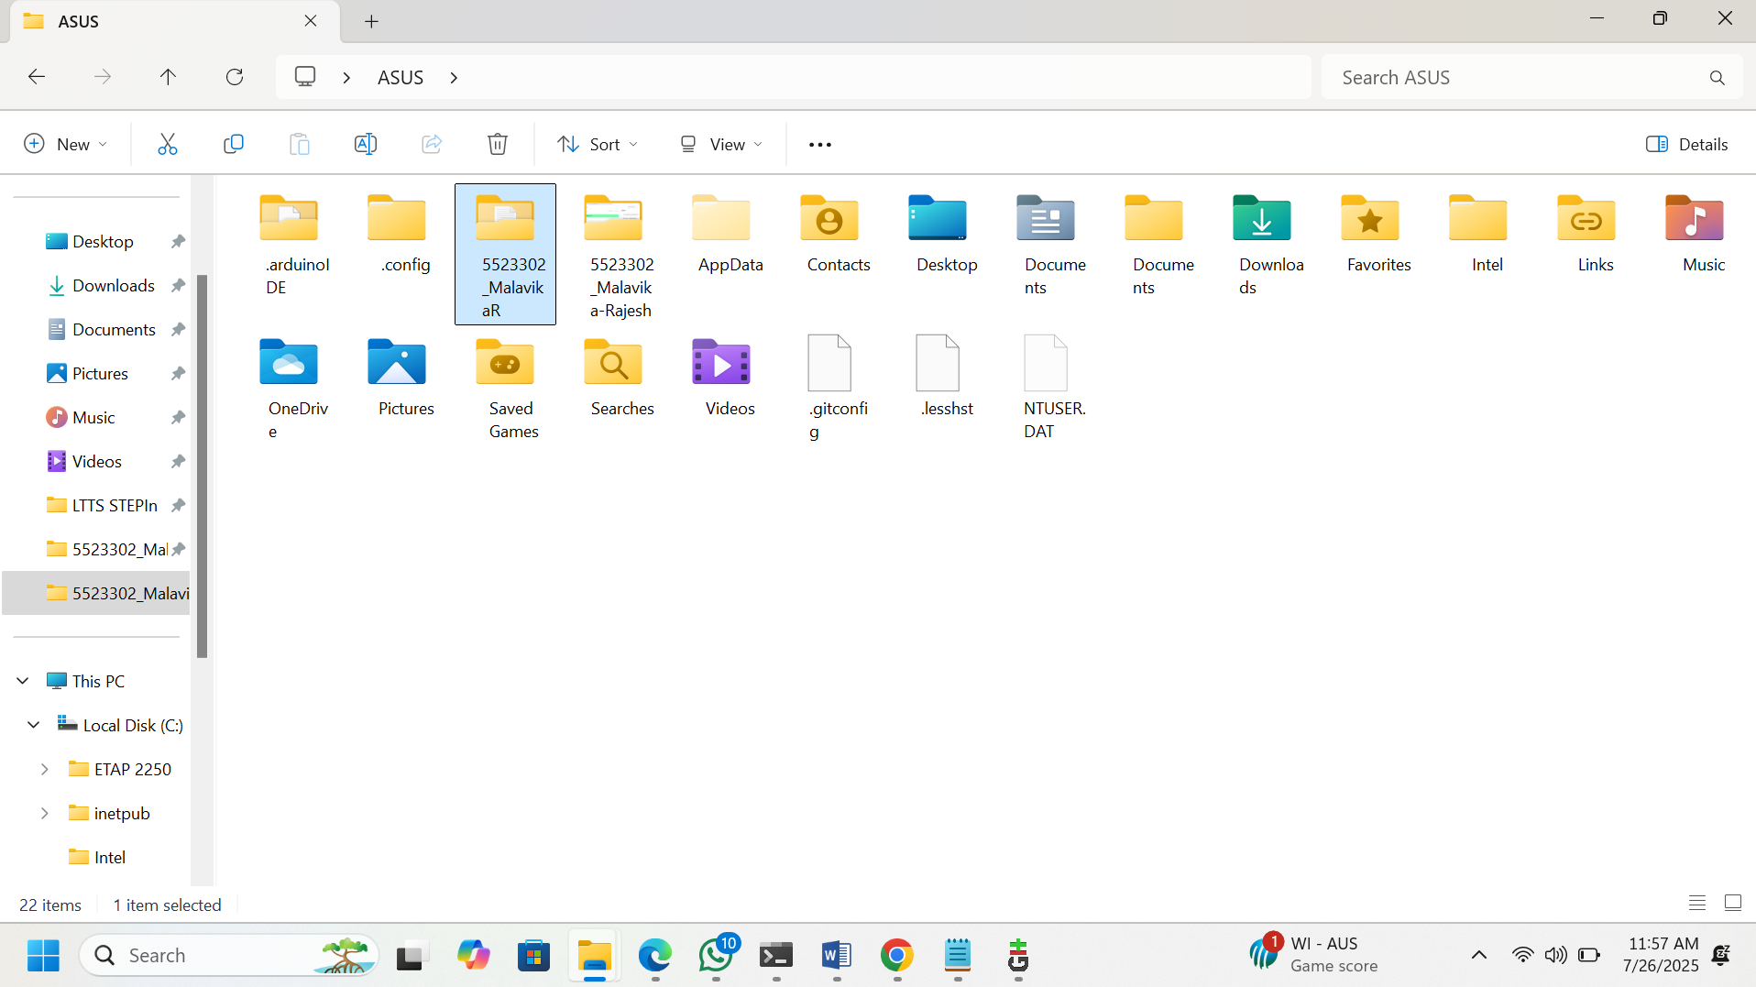

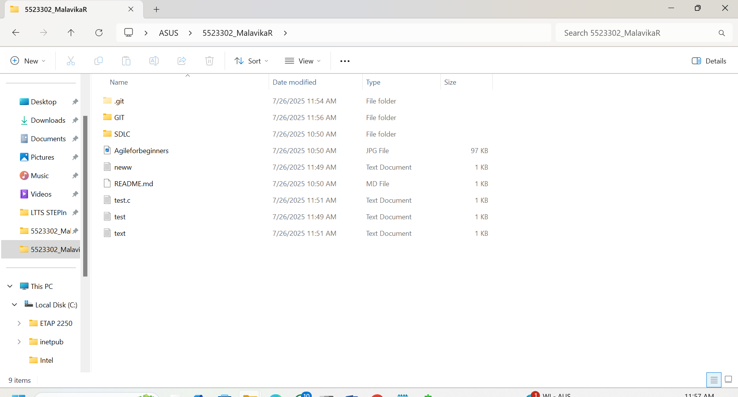

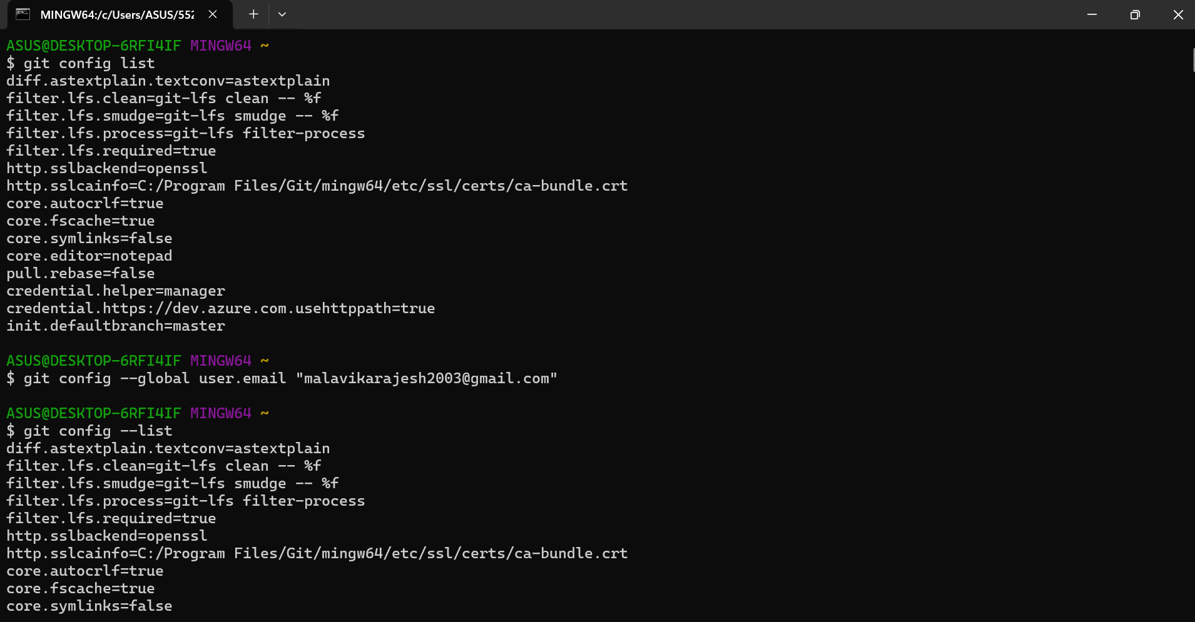

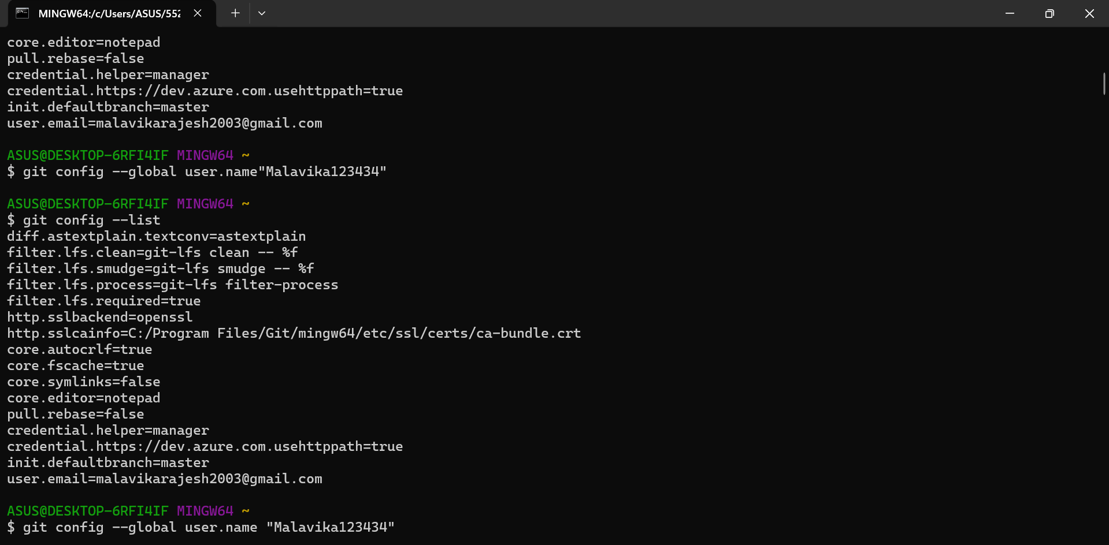

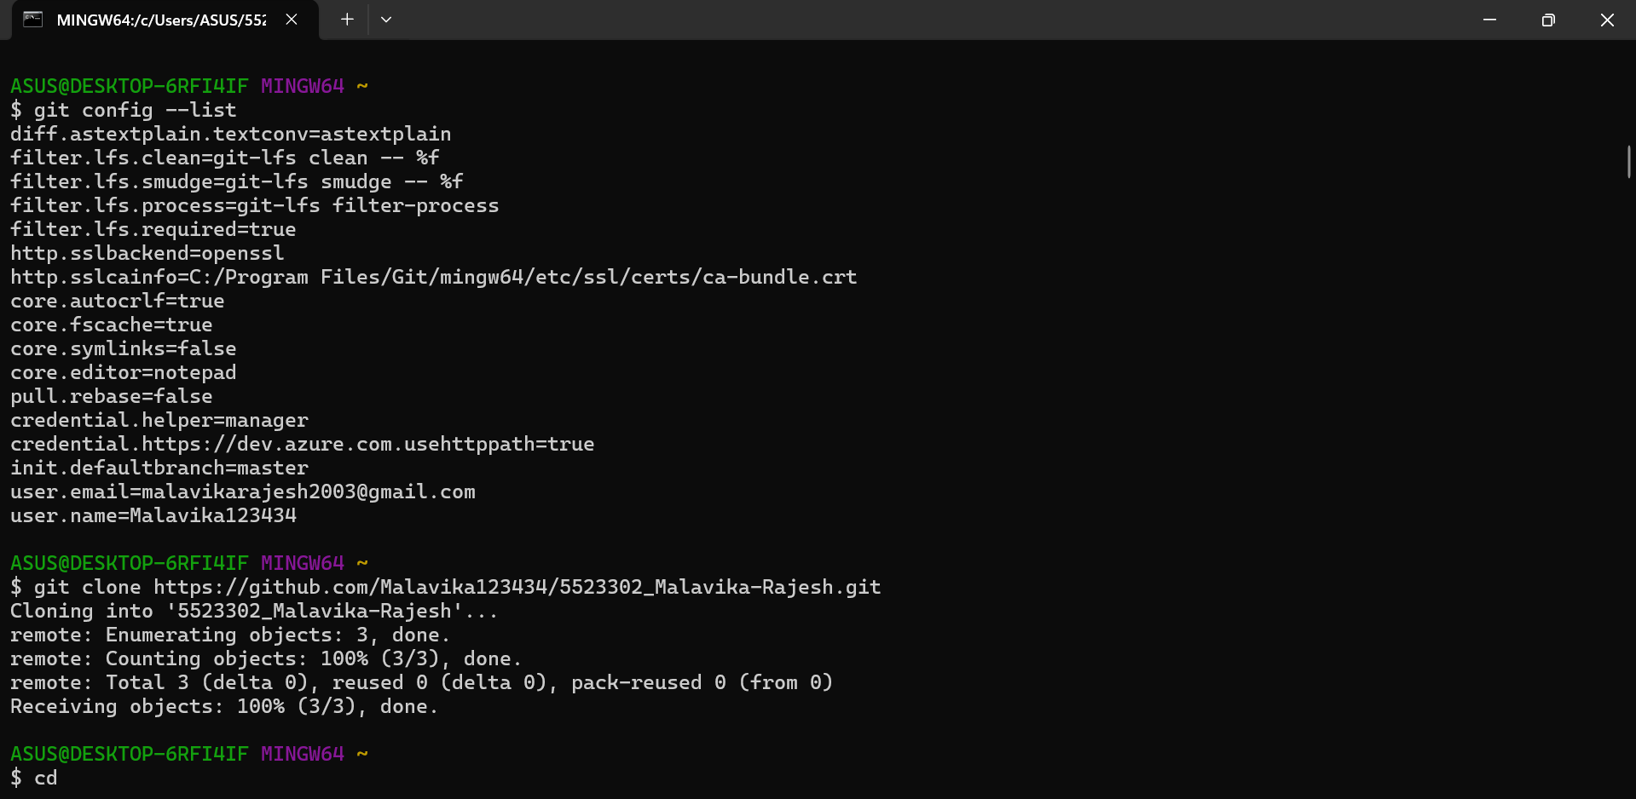

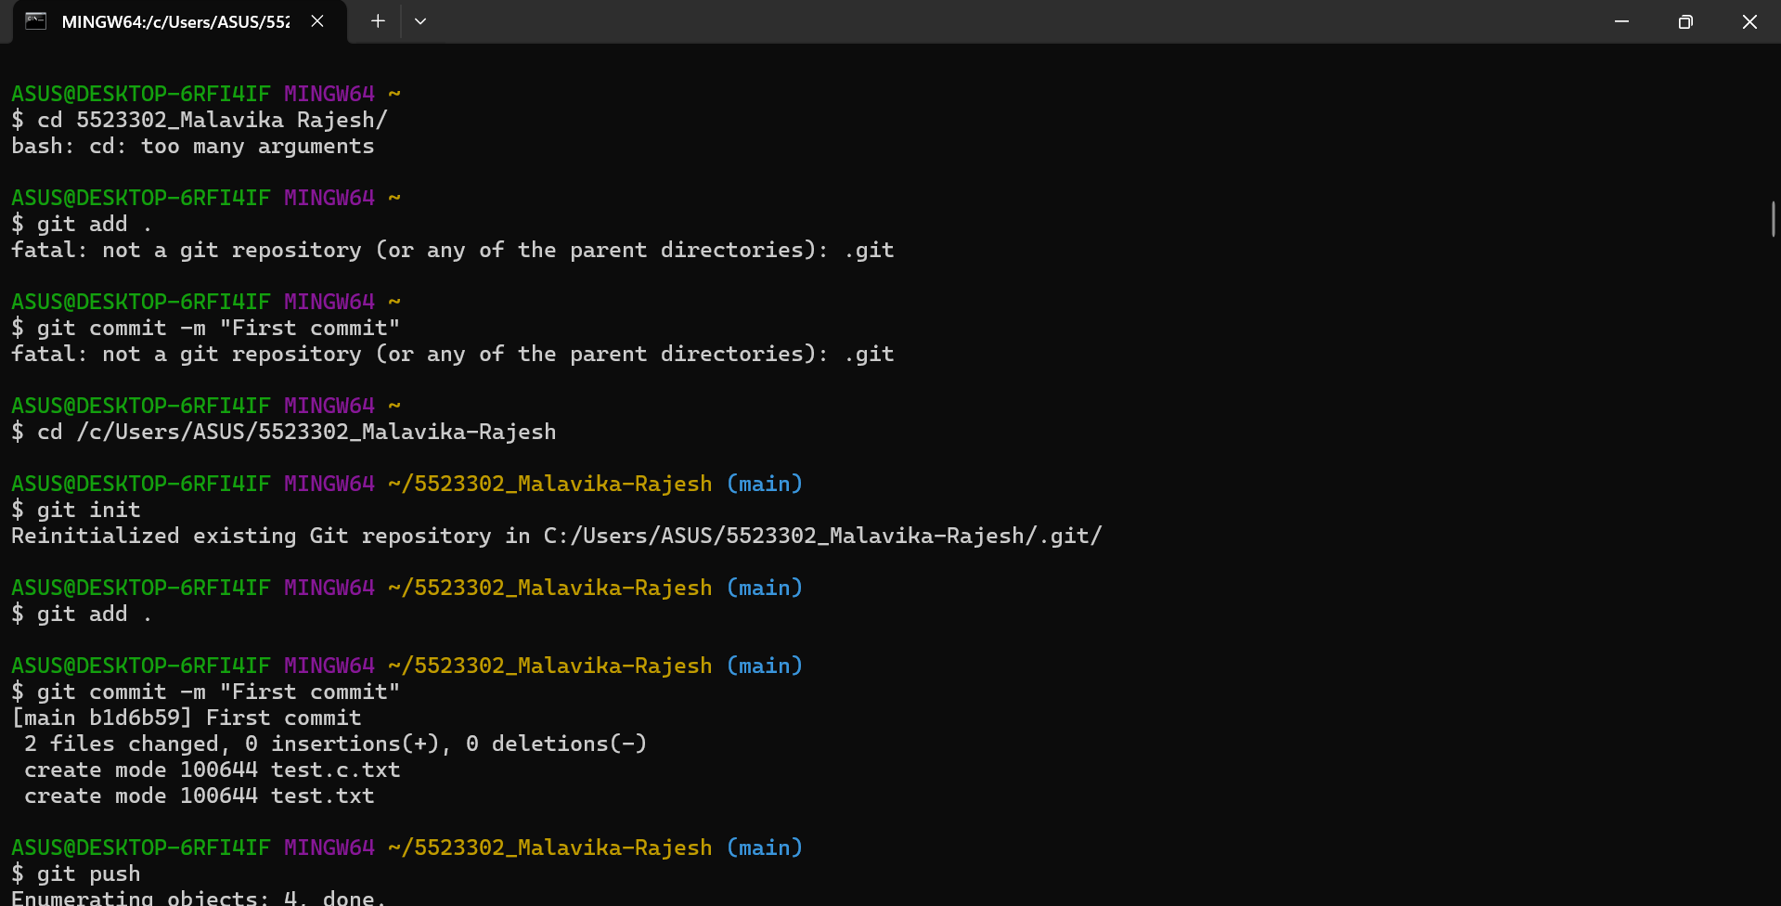

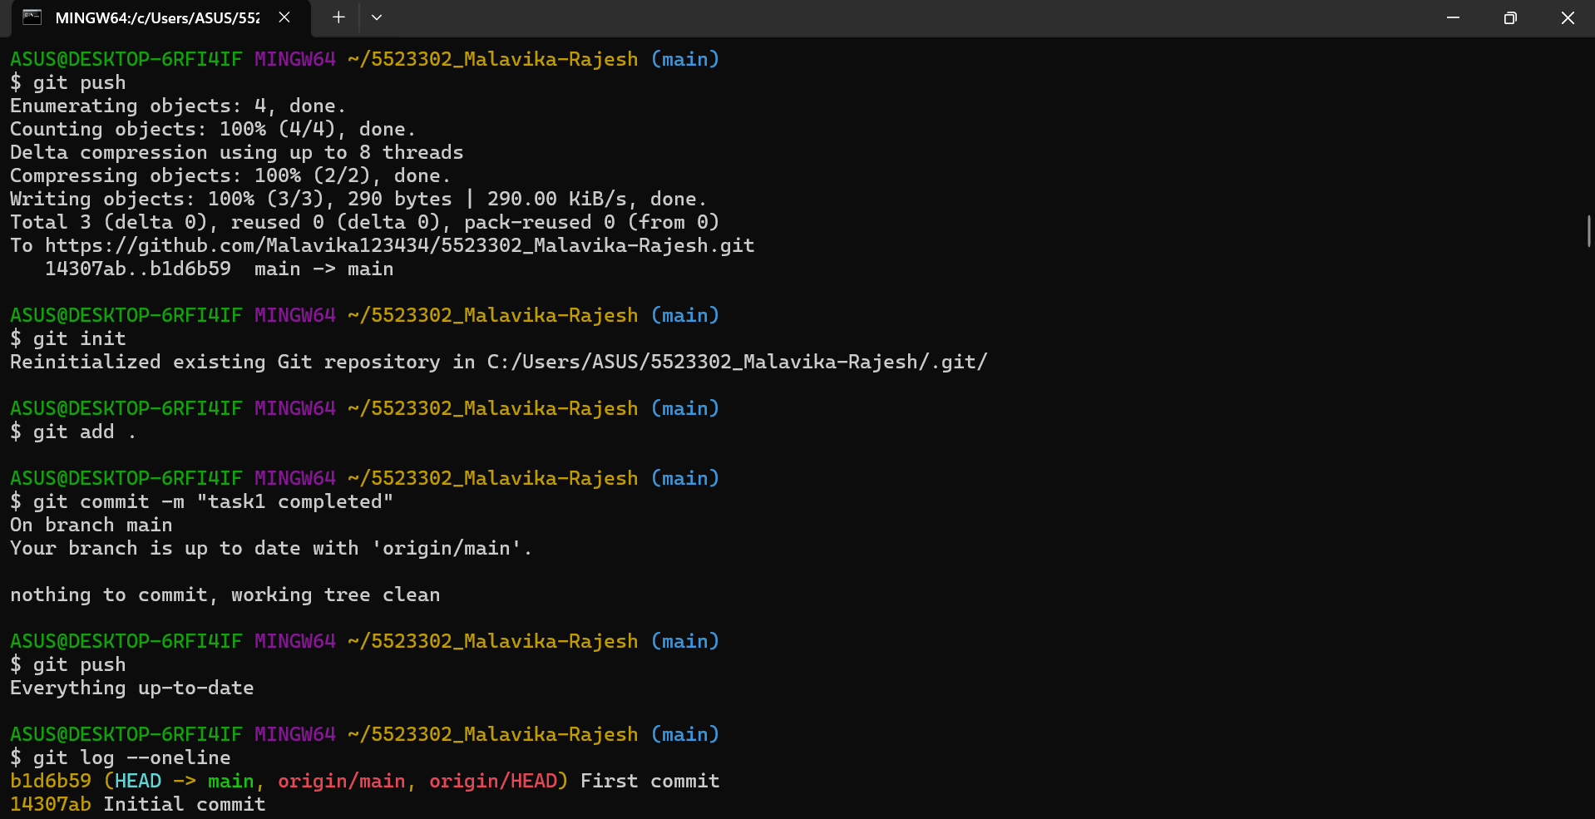 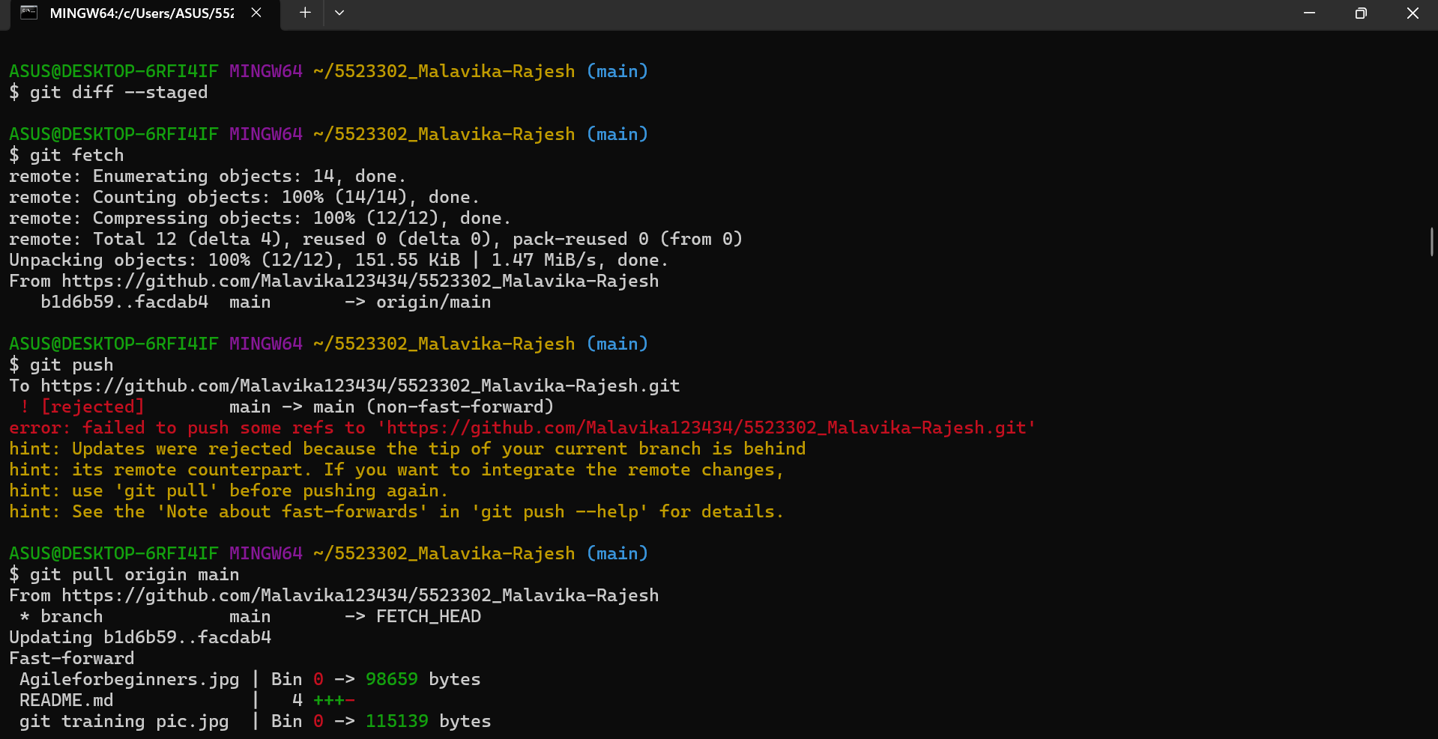 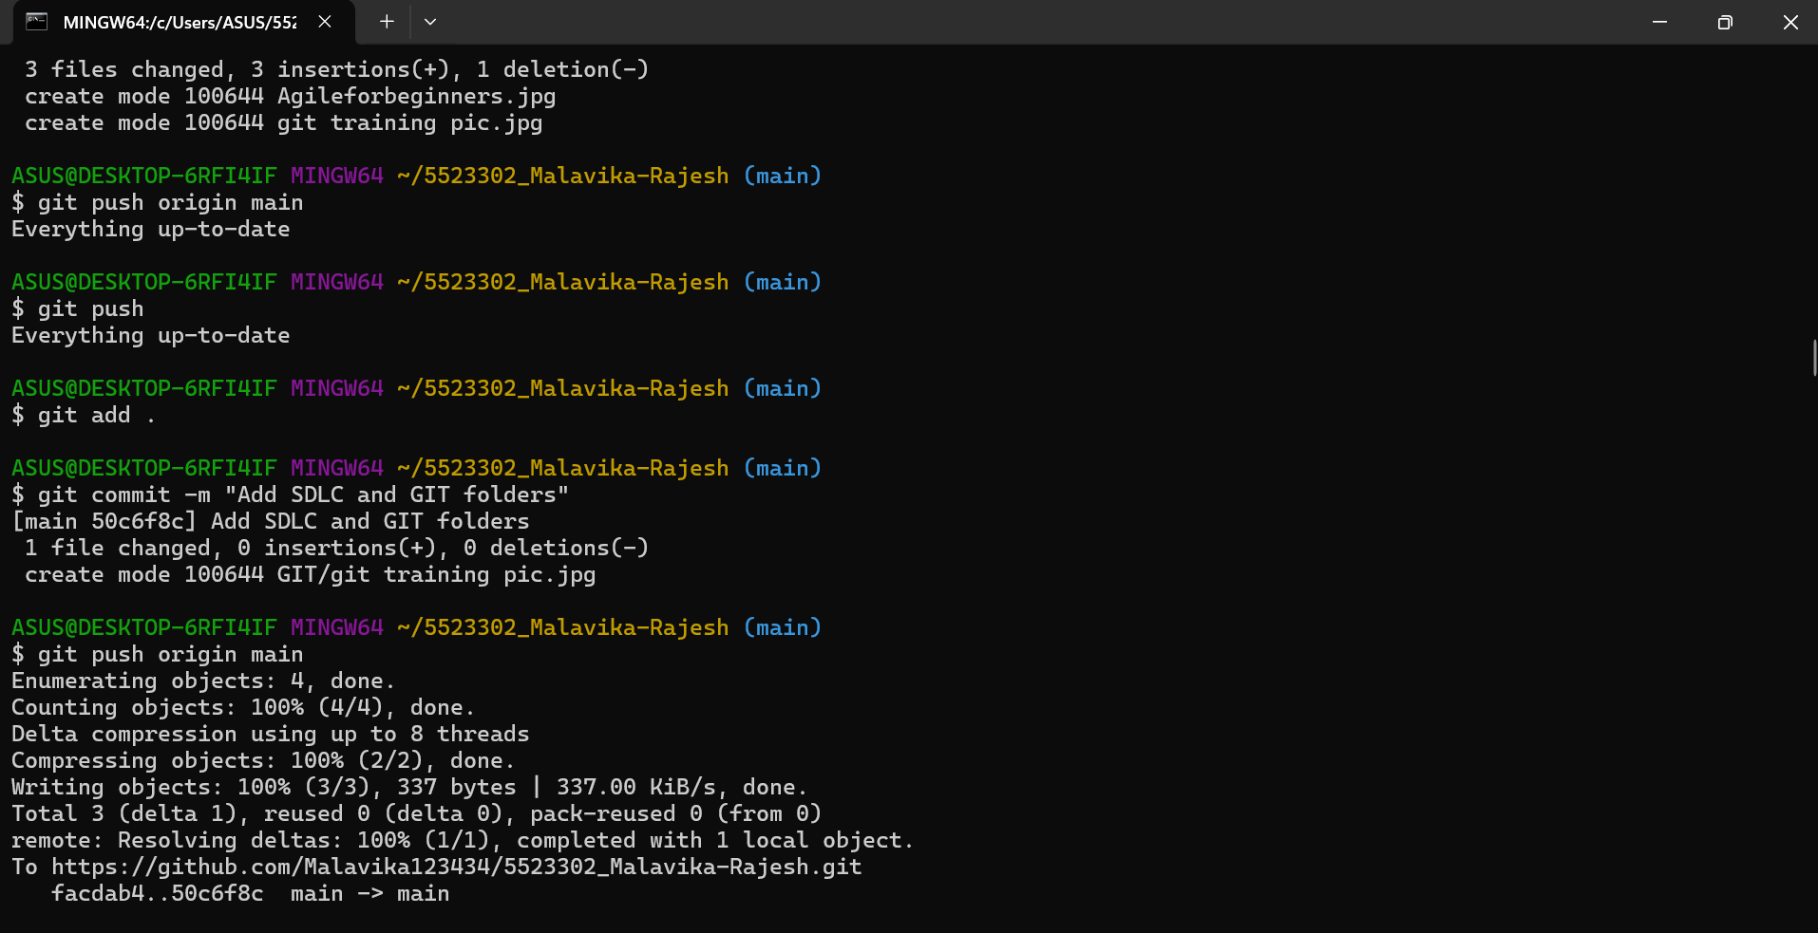 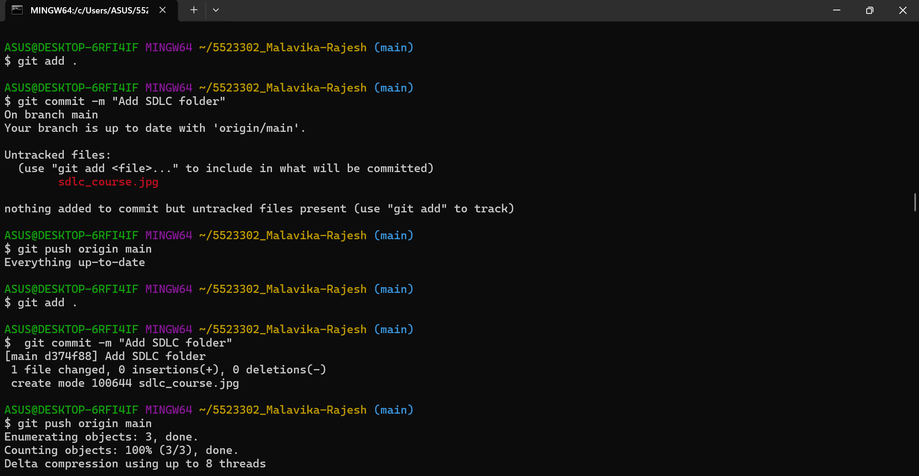 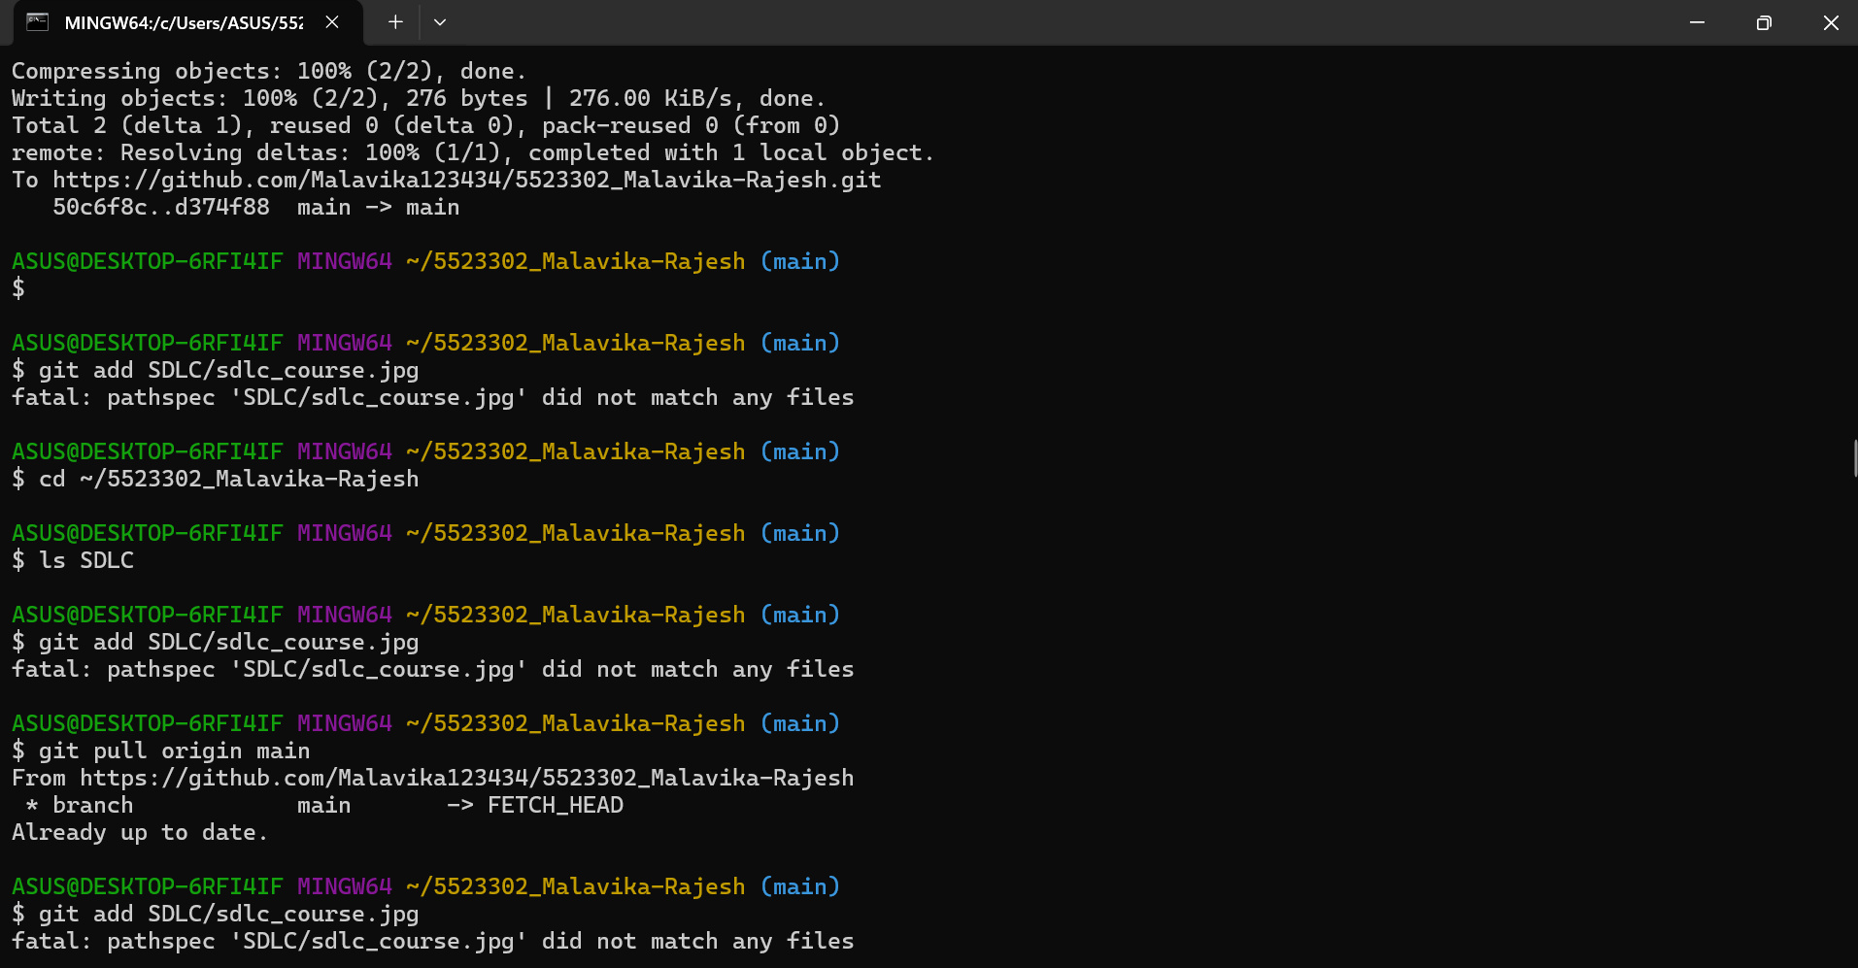 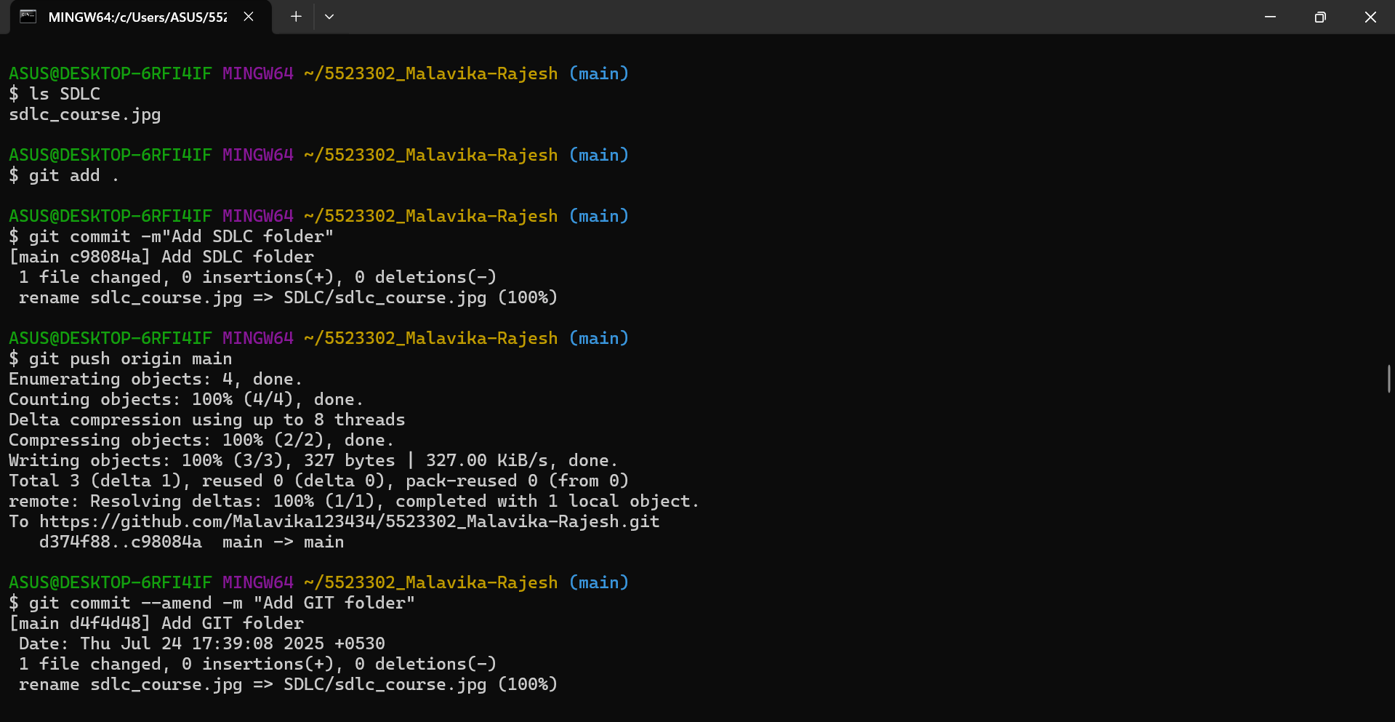 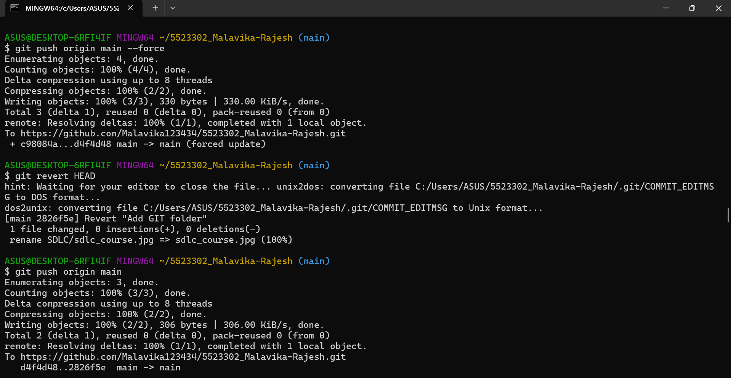 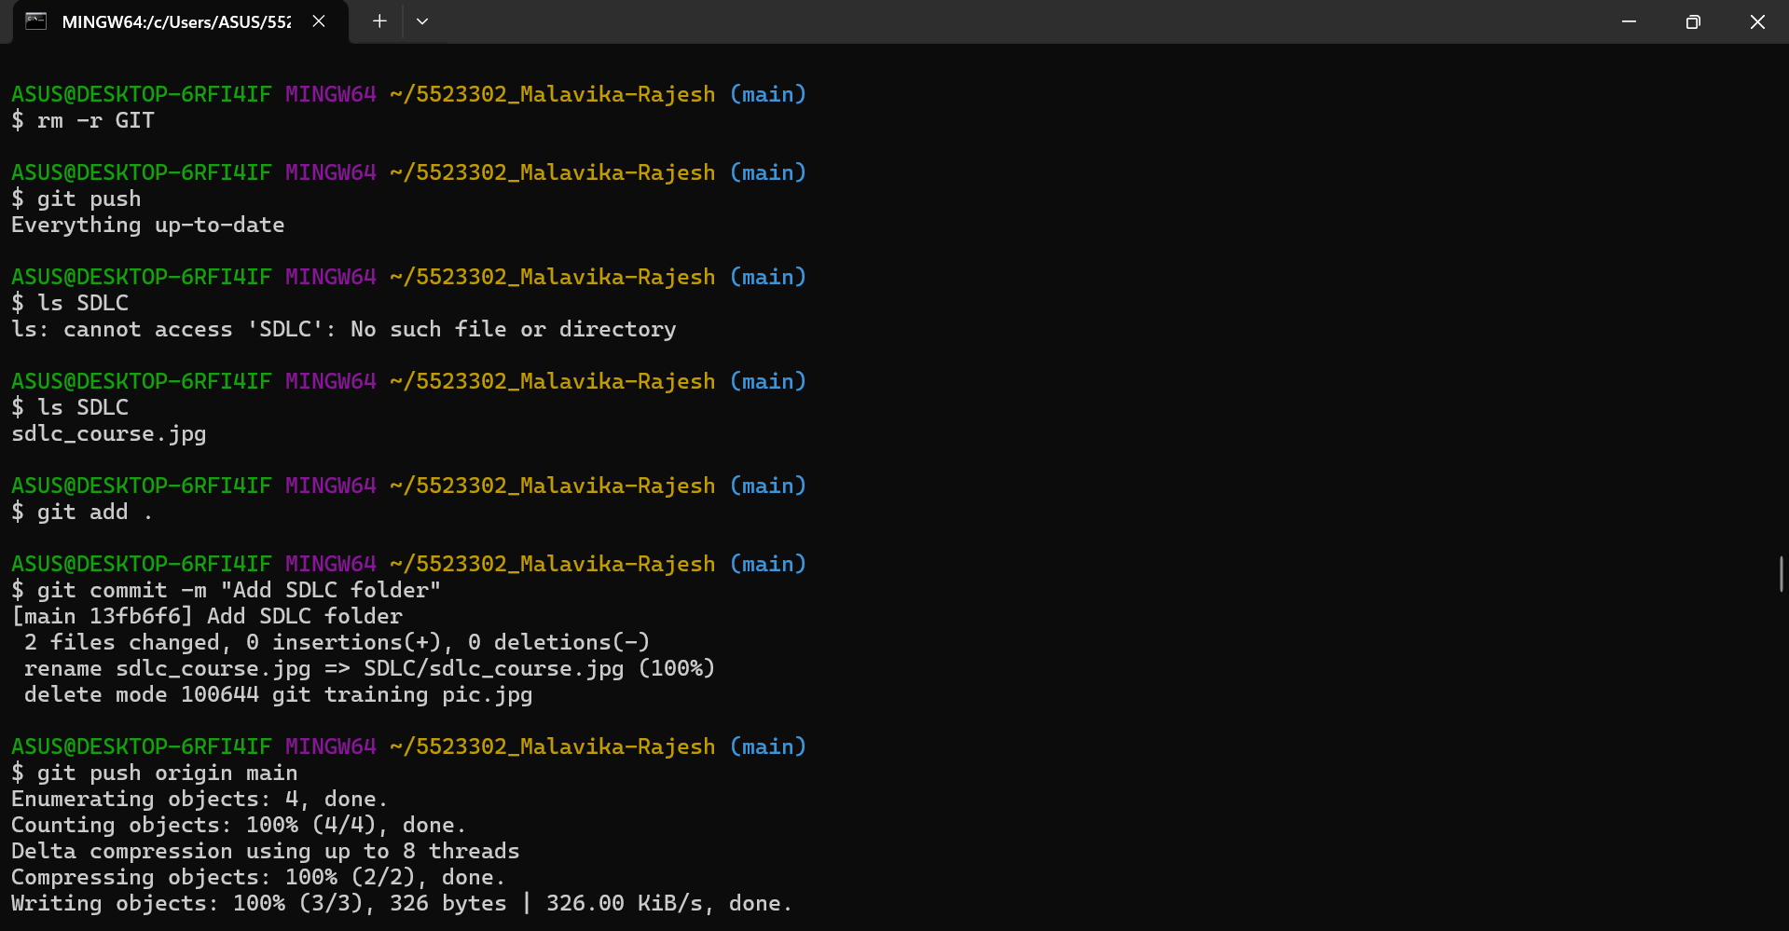 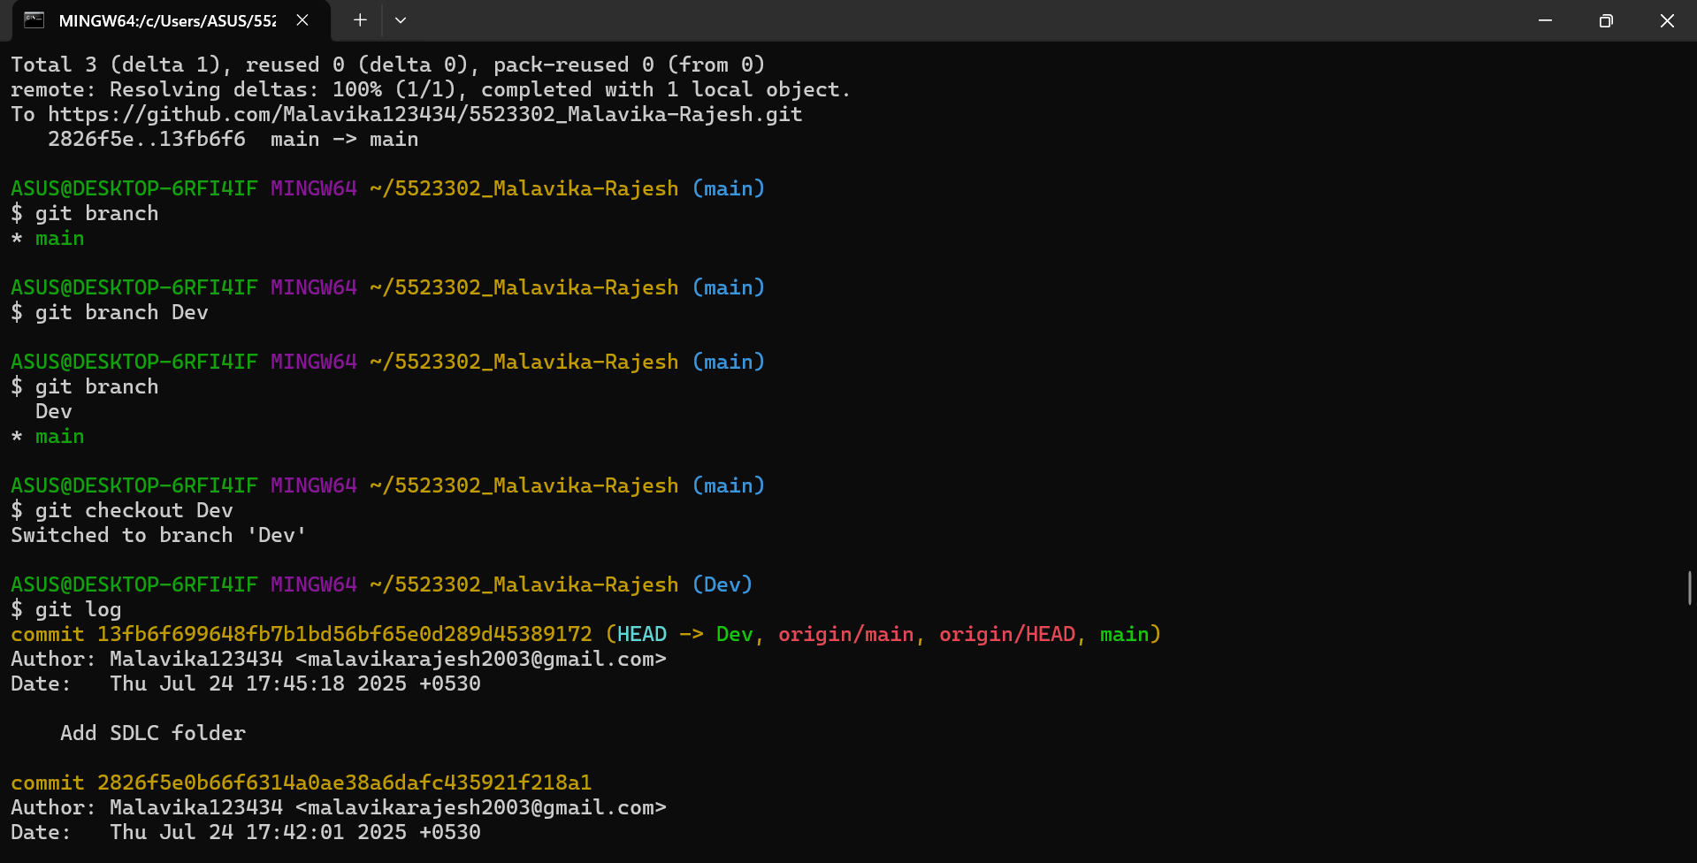 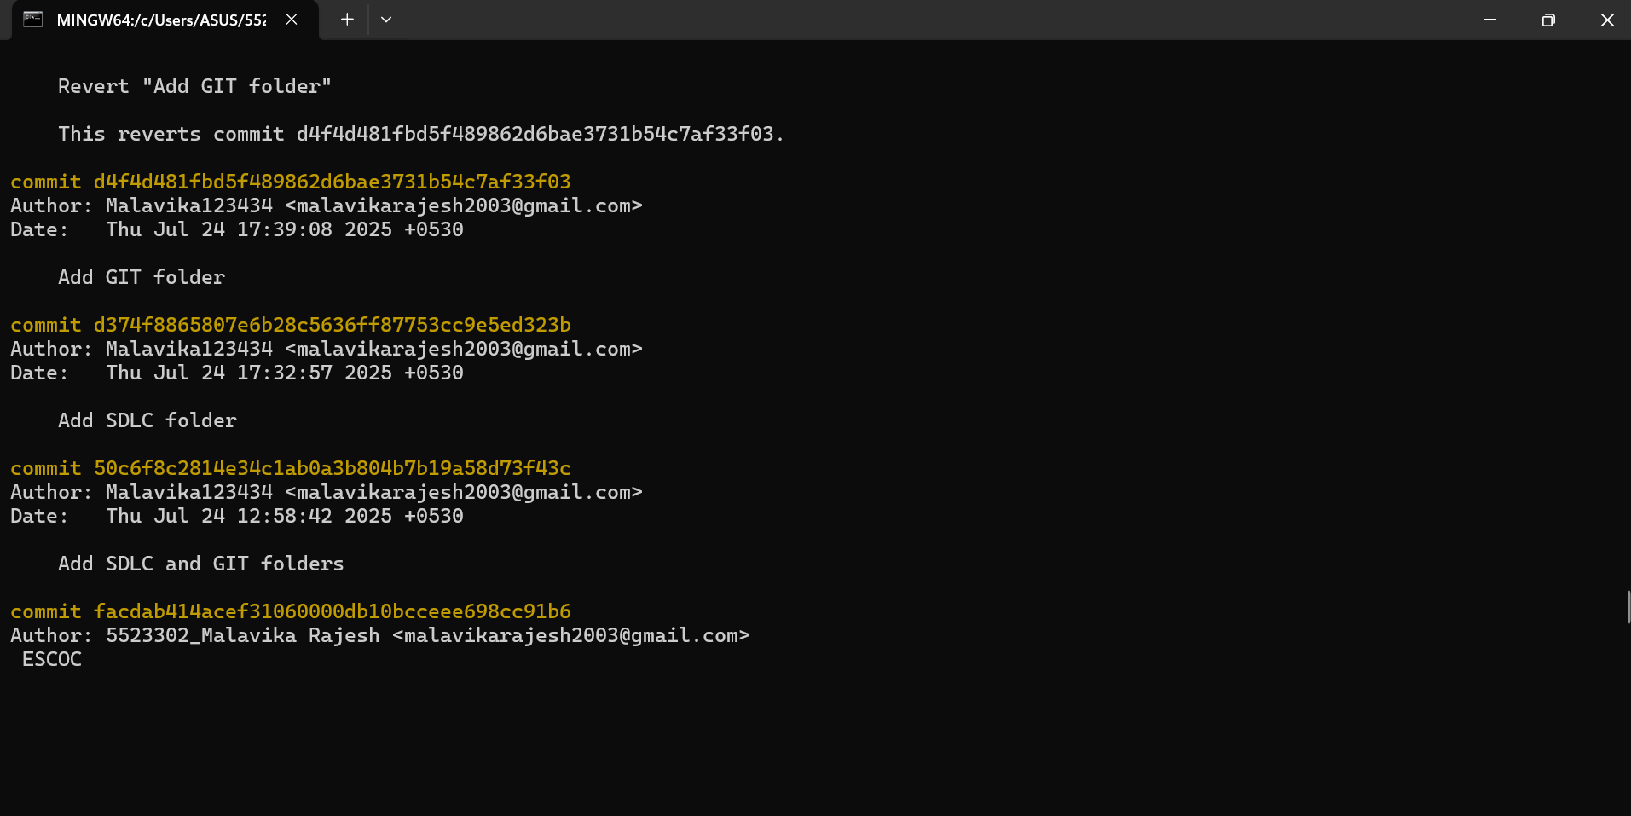 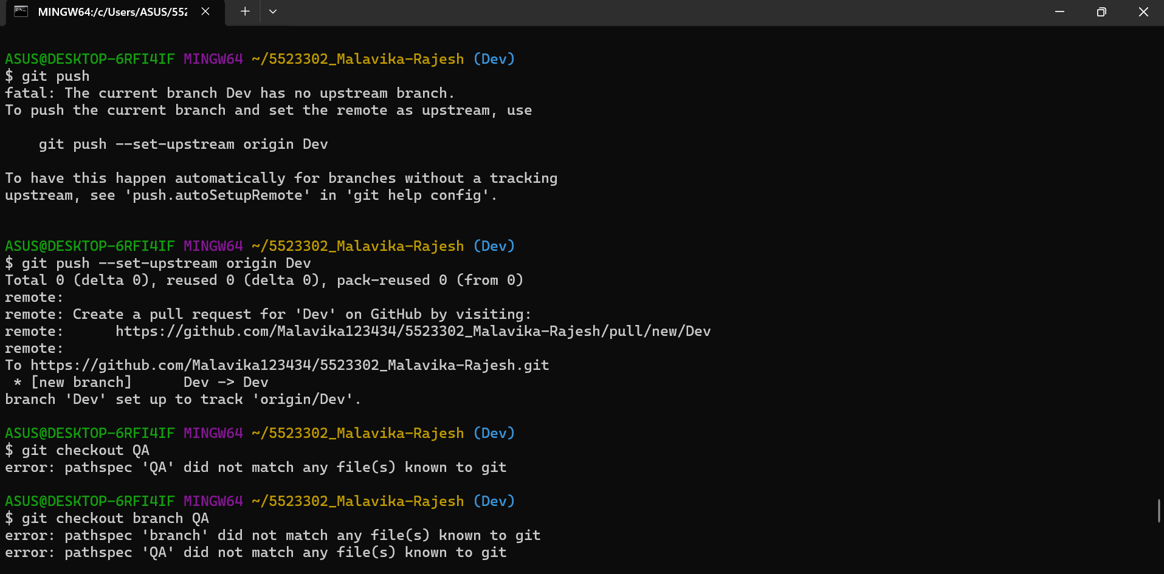 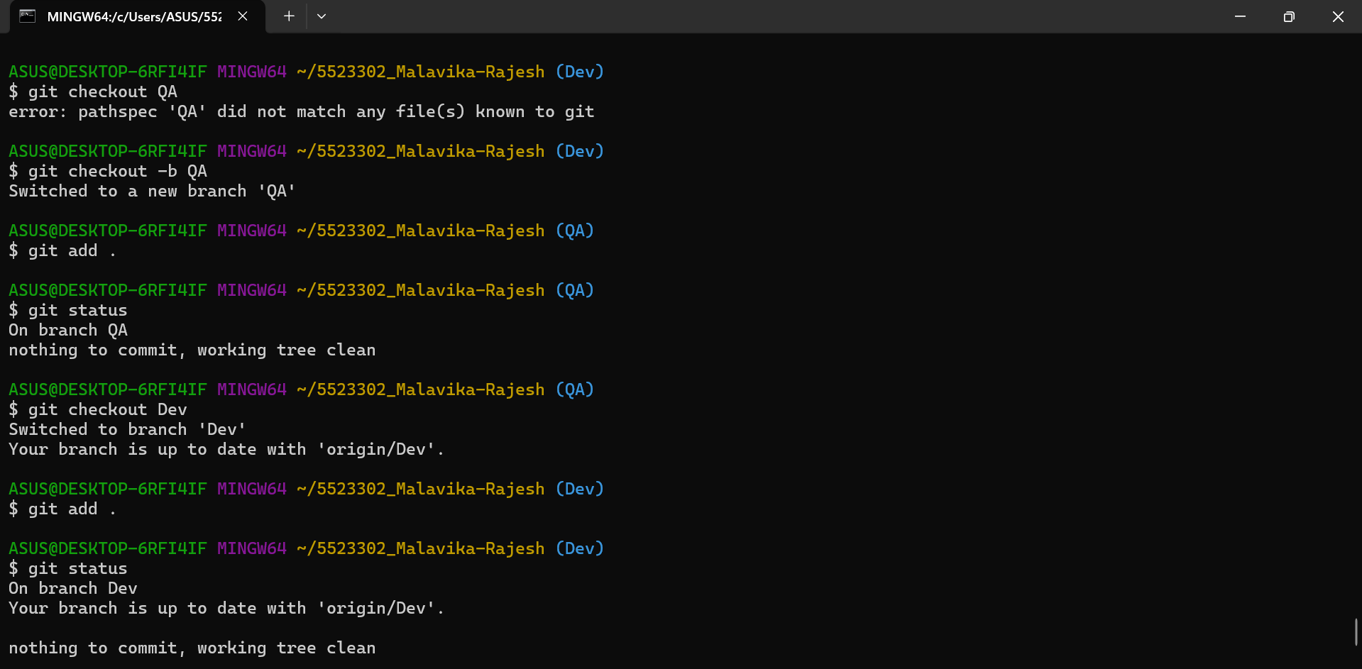 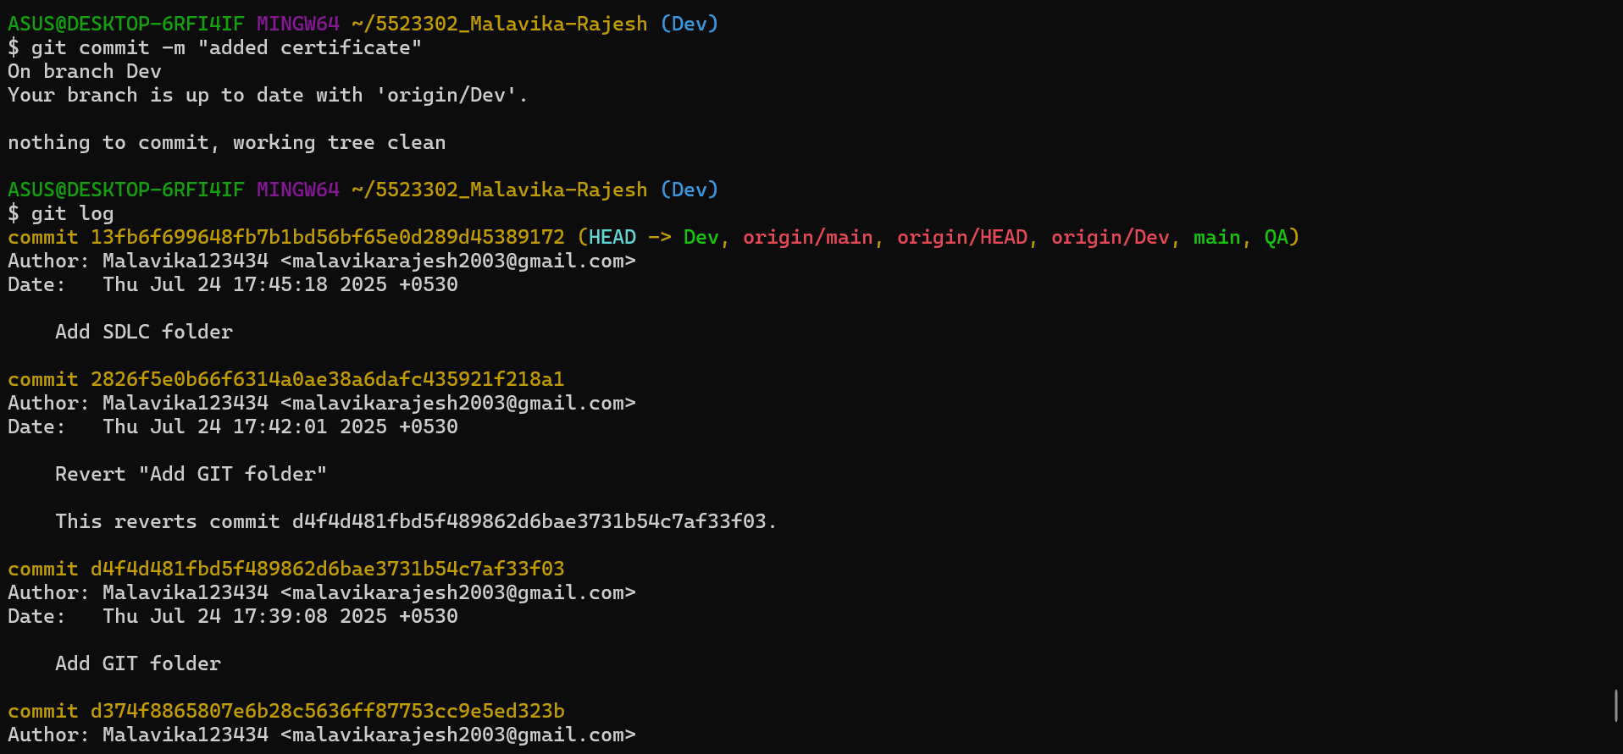

Text version:

ASUS@DESKTOP-6RFI4IF MINGW64 ~

$ git config list

diff.astextplain.textconv=astextplain

filter.lfs.clean=git-lfs clean -- %f

filter.lfs.smudge=git-lfs smudge -- %f

filter.lfs.process=git-lfs filter-process

filter.lfs.required=true

http.sslbackend=openssl

http.sslcainfo=C:/Program Files/Git/mingw64/etc/ssl/certs/ca-bundle.crt

core.autocrlf=true

core.fscache=true

core.symlinks=false

core.editor=notepad

pull.rebase=false

credential.helper=manager

credential.https://dev.azure.com.usehttppath=true

init.defaultbranch=master

ASUS@DESKTOP-6RFI4IF MINGW64 ~

$ git config --global user.email "malavikarajesh2003@gmail.com"

ASUS@DESKTOP-6RFI4IF MINGW64 ~

$ git config --list

diff.astextplain.textconv=astextplain

filter.lfs.clean=git-lfs clean -- %f

filter.lfs.smudge=git-lfs smudge -- %f

filter.lfs.process=git-lfs filter-process

filter.lfs.required=true

http.sslbackend=openssl

http.sslcainfo=C:/Program Files/Git/mingw64/etc/ssl/certs/ca-bundle.crt

core.autocrlf=true

core.fscache=true

core.symlinks=false

core.editor=notepad

pull.rebase=false

credential.helper=manager

credential.https://dev.azure.com.usehttppath=true

init.defaultbranch=master

user.email=malavikarajesh2003@gmail.com

ASUS@DESKTOP-6RFI4IF MINGW64 ~

$ git config --global user.name"Malavika123434"

ASUS@DESKTOP-6RFI4IF MINGW64 ~

$ git config --list

diff.astextplain.textconv=astextplain

filter.lfs.clean=git-lfs clean -- %f

filter.lfs.smudge=git-lfs smudge -- %f

filter.lfs.process=git-lfs filter-process

filter.lfs.required=true

http.sslbackend=openssl

http.sslcainfo=C:/Program Files/Git/mingw64/etc/ssl/certs/ca-bundle.crt

core.autocrlf=true

core.fscache=true

core.symlinks=false

core.editor=notepad

pull.rebase=false

credential.helper=manager

credential.https://dev.azure.com.usehttppath=true

init.defaultbranch=master

user.email=malavikarajesh2003@gmail.com

ASUS@DESKTOP-6RFI4IF MINGW64 ~

$ git config --global user.name "Malavika123434"

ASUS@DESKTOP-6RFI4IF MINGW64 ~

$ git config --list

diff.astextplain.textconv=astextplain

filter.lfs.clean=git-lfs clean -- %f

filter.lfs.smudge=git-lfs smudge -- %f

filter.lfs.process=git-lfs filter-process

filter.lfs.required=true

http.sslbackend=openssl

http.sslcainfo=C:/Program Files/Git/mingw64/etc/ssl/certs/ca-bundle.crt

core.autocrlf=true

core.fscache=true

core.symlinks=false

core.editor=notepad

pull.rebase=false

credential.helper=manager

credential.https://dev.azure.com.usehttppath=true

init.defaultbranch=master

user.email=malavikarajesh2003@gmail.com

user.name=Malavika123434

ASUS@DESKTOP-6RFI4IF MINGW64 ~

$ git clone https://github.com/Malavika123434/5523302_Malavika-Rajesh.git

Cloning into '5523302_Malavika-Rajesh'...

remote: Enumerating objects: 3, done.

remote: Counting objects: 100% (3/3), done.

remote: Total 3 (delta 0), reused 0 (delta 0), pack-reused 0 (from 0)

Receiving objects: 100% (3/3), done.

ASUS@DESKTOP-6RFI4IF MINGW64 ~

$ cd

ASUS@DESKTOP-6RFI4IF MINGW64 ~

$ cd 5523302_Malavika Rajesh/

bash: cd: too many arguments

ASUS@DESKTOP-6RFI4IF MINGW64 ~

$ git add .

fatal: not a git repository (or any of the parent directories): .git

ASUS@DESKTOP-6RFI4IF MINGW64 ~

$ git commit -m "First commit"

fatal: not a git repository (or any of the parent directories): .git

ASUS@DESKTOP-6RFI4IF MINGW64 ~

$ cd /c/Users/ASUS/5523302_Malavika-Rajesh

ASUS@DESKTOP-6RFI4IF MINGW64 ~/5523302_Malavika-Rajesh (main)

$ git init

Reinitialized existing Git repository in C:/Users/ASUS/5523302_Malavika-Rajesh/.git/

ASUS@DESKTOP-6RFI4IF MINGW64 ~/5523302_Malavika-Rajesh (main)

$ git add .

ASUS@DESKTOP-6RFI4IF MINGW64 ~/5523302_Malavika-Rajesh (main)

$ git commit -m "First commit"

[main b1d6b59] First commit

2 files changed, 0 insertions(+), 0 deletions(-)

create mode 100644 test.c.txt

create mode 100644 test.txt

ASUS@DESKTOP-6RFI4IF MINGW64 ~/5523302_Malavika-Rajesh (main)

$ git push

Enumerating objects: 4, done.

Counting objects: 100% (4/4), done.

Delta compression using up to 8 threads

Compressing objects: 100% (2/2), done.

Writing objects: 100% (3/3), 290 bytes | 290.00 KiB/s, done.

Total 3 (delta 0), reused 0 (delta 0), pack-reused 0 (from 0)

To https://github.com/Malavika123434/5523302_Malavika-Rajesh.git

14307ab..b1d6b59 main -> main

ASUS@DESKTOP-6RFI4IF MINGW64 ~/5523302_Malavika-Rajesh (main)

$ git init

Reinitialized existing Git repository in C:/Users/ASUS/5523302_Malavika-Rajesh/.git/

ASUS@DESKTOP-6RFI4IF MINGW64 ~/5523302_Malavika-Rajesh (main)

$ git add .

ASUS@DESKTOP-6RFI4IF MINGW64 ~/5523302_Malavika-Rajesh (main)

$ git commit -m "task1 completed"

On branch main

Your branch is up to date with 'origin/main'.

nothing to commit, working tree clean

ASUS@DESKTOP-6RFI4IF MINGW64 ~/5523302_Malavika-Rajesh (main)

$ git push

Everything up-to-date

ASUS@DESKTOP-6RFI4IF MINGW64 ~/5523302_Malavika-Rajesh (main)

$ git log --oneline

b1d6b59 (HEAD -> main, origin/main, origin/HEAD) First commit

14307ab Initial commit

ASUS@DESKTOP-6RFI4IF MINGW64 ~/5523302_Malavika-Rajesh (main)

$ git diff --staged

ASUS@DESKTOP-6RFI4IF MINGW64 ~/5523302_Malavika-Rajesh (main)

$ git fetch

remote: Enumerating objects: 14, done.

remote: Counting objects: 100% (14/14), done.

remote: Compressing objects: 100% (12/12), done.

remote: Total 12 (delta 4), reused 0 (delta 0), pack-reused 0 (from 0)

Unpacking objects: 100% (12/12), 151.55 KiB | 1.47 MiB/s, done.

From https://github.com/Malavika123434/5523302_Malavika-Rajesh

b1d6b59..facdab4 main -> origin/main

ASUS@DESKTOP-6RFI4IF MINGW64 ~/5523302_Malavika-Rajesh (main)

$ git push

To https://github.com/Malavika123434/5523302_Malavika-Rajesh.git

! [rejected] main -> main (non-fast-forward)

error: failed to push some refs to 'https://github.com/Malavika123434/5523302_Malavika-Rajesh.git'

hint: Updates were rejected because the tip of your current branch is behind

hint: its remote counterpart. If you want to integrate the remote changes,

hint: use 'git pull' before pushing again.

hint: See the 'Note about fast-forwards' in 'git push --help' for details.

ASUS@DESKTOP-6RFI4IF MINGW64 ~/5523302_Malavika-Rajesh (main)

$ git pull origin main

From https://github.com/Malavika123434/5523302_Malavika-Rajesh

* branch main -> FETCH_HEAD

Updating b1d6b59..facdab4

Fast-forward

Agileforbeginners.jpg | Bin 0 -> 98659 bytes

README.md | 4 +++-

git training pic.jpg | Bin 0 -> 115139 bytes

3 files changed, 3 insertions(+), 1 deletion(-)

create mode 100644 Agileforbeginners.jpg

create mode 100644 git training pic.jpg

ASUS@DESKTOP-6RFI4IF MINGW64 ~/5523302_Malavika-Rajesh (main)

$ git push origin main

Everything up-to-date

ASUS@DESKTOP-6RFI4IF MINGW64 ~/5523302_Malavika-Rajesh (main)

$ git push

Everything up-to-date

ASUS@DESKTOP-6RFI4IF MINGW64 ~/5523302_Malavika-Rajesh (main)

$ git add .

ASUS@DESKTOP-6RFI4IF MINGW64 ~/5523302_Malavika-Rajesh (main)

$ git commit -m "Add SDLC and GIT folders"

[main 50c6f8c] Add SDLC and GIT folders

1 file changed, 0 insertions(+), 0 deletions(-)

create mode 100644 GIT/git training pic.jpg

ASUS@DESKTOP-6RFI4IF MINGW64 ~/5523302_Malavika-Rajesh (main)

$ git push origin main

Enumerating objects: 4, done.

Counting objects: 100% (4/4), done.

Delta compression using up to 8 threads

Compressing objects: 100% (2/2), done.

Writing objects: 100% (3/3), 337 bytes | 337.00 KiB/s, done.

Total 3 (delta 1), reused 0 (delta 0), pack-reused 0 (from 0)

remote: Resolving deltas: 100% (1/1), completed with 1 local object.

To https://github.com/Malavika123434/5523302_Malavika-Rajesh.git

facdab4..50c6f8c main -> main

ASUS@DESKTOP-6RFI4IF MINGW64 ~/5523302_Malavika-Rajesh (main)

$ git add .

ASUS@DESKTOP-6RFI4IF MINGW64 ~/5523302_Malavika-Rajesh (main)

$ git commit -m "Add SDLC folder"

On branch main

Your branch is up to date with 'origin/main'.

Untracked files:

(use "git add <file>..." to include in what will be committed)

sdlc_course.jpg

nothing added to commit but untracked files present (use "git add" to track)

ASUS@DESKTOP-6RFI4IF MINGW64 ~/5523302_Malavika-Rajesh (main)

$ git push origin main

Everything up-to-date

ASUS@DESKTOP-6RFI4IF MINGW64 ~/5523302_Malavika-Rajesh (main)

$ git add .

ASUS@DESKTOP-6RFI4IF MINGW64 ~/5523302_Malavika-Rajesh (main)

$ git commit -m "Add SDLC folder"

[main d374f88] Add SDLC folder

1 file changed, 0 insertions(+), 0 deletions(-)

create mode 100644 sdlc_course.jpg

ASUS@DESKTOP-6RFI4IF MINGW64 ~/5523302_Malavika-Rajesh (main)

$ git push origin main

Enumerating objects: 3, done.

Counting objects: 100% (3/3), done.

Delta compression using up to 8 threads

Compressing objects: 100% (2/2), done.

Writing objects: 100% (2/2), 276 bytes | 276.00 KiB/s, done.

Total 2 (delta 1), reused 0 (delta 0), pack-reused 0 (from 0)

remote: Resolving deltas: 100% (1/1), completed with 1 local object.

To https://github.com/Malavika123434/5523302_Malavika-Rajesh.git

50c6f8c..d374f88 main -> main

ASUS@DESKTOP-6RFI4IF MINGW64 ~/5523302_Malavika-Rajesh (main)

$

ASUS@DESKTOP-6RFI4IF MINGW64 ~/5523302_Malavika-Rajesh (main)

$ git add SDLC/sdlc_course.jpg

fatal: pathspec 'SDLC/sdlc_course.jpg' did not match any files

ASUS@DESKTOP-6RFI4IF MINGW64 ~/5523302_Malavika-Rajesh (main)

$ cd ~/5523302_Malavika-Rajesh

ASUS@DESKTOP-6RFI4IF MINGW64 ~/5523302_Malavika-Rajesh (main)

$ ls SDLC

ASUS@DESKTOP-6RFI4IF MINGW64 ~/5523302_Malavika-Rajesh (main)

$ git add SDLC/sdlc_course.jpg

fatal: pathspec 'SDLC/sdlc_course.jpg' did not match any files

ASUS@DESKTOP-6RFI4IF MINGW64 ~/5523302_Malavika-Rajesh (main)

$ git pull origin main

From https://github.com/Malavika123434/5523302_Malavika-Rajesh

* branch main -> FETCH_HEAD

Already up to date.

ASUS@DESKTOP-6RFI4IF MINGW64 ~/5523302_Malavika-Rajesh (main)

$ git add SDLC/sdlc_course.jpg

fatal: pathspec 'SDLC/sdlc_course.jpg' did not match any files

ASUS@DESKTOP-6RFI4IF MINGW64 ~/5523302_Malavika-Rajesh (main)

$ ls SDLC

sdlc_course.jpg

ASUS@DESKTOP-6RFI4IF MINGW64 ~/5523302_Malavika-Rajesh (main)

$ git add .

ASUS@DESKTOP-6RFI4IF MINGW64 ~/5523302_Malavika-Rajesh (main)

$ git commit -m"Add SDLC folder"

[main c98084a] Add SDLC folder

1 file changed, 0 insertions(+), 0 deletions(-)

rename sdlc_course.jpg => SDLC/sdlc_course.jpg (100%)

ASUS@DESKTOP-6RFI4IF MINGW64 ~/5523302_Malavika-Rajesh (main)

$ git push origin main

Enumerating objects: 4, done.

Counting objects: 100% (4/4), done.

Delta compression using up to 8 threads

Compressing objects: 100% (2/2), done.

Writing objects: 100% (3/3), 327 bytes | 327.00 KiB/s, done.

Total 3 (delta 1), reused 0 (delta 0), pack-reused 0 (from 0)

remote: Resolving deltas: 100% (1/1), completed with 1 local object.

To https://github.com/Malavika123434/5523302_Malavika-Rajesh.git

d374f88..c98084a main -> main

ASUS@DESKTOP-6RFI4IF MINGW64 ~/5523302_Malavika-Rajesh (main)

$ git commit --amend -m "Add GIT folder"

[main d4f4d48] Add GIT folder

Date: Thu Jul 24 17:39:08 2025 +0530

1 file changed, 0 insertions(+), 0 deletions(-)

rename sdlc_course.jpg => SDLC/sdlc_course.jpg (100%)

ASUS@DESKTOP-6RFI4IF MINGW64 ~/5523302_Malavika-Rajesh (main)

$ git push origin main --force

Enumerating objects: 4, done.

Counting objects: 100% (4/4), done.

Delta compression using up to 8 threads

Compressing objects: 100% (2/2), done.

Writing objects: 100% (3/3), 330 bytes | 330.00 KiB/s, done.

Total 3 (delta 1), reused 0 (delta 0), pack-reused 0 (from 0)

remote: Resolving deltas: 100% (1/1), completed with 1 local object.

To https://github.com/Malavika123434/5523302_Malavika-Rajesh.git

+ c98084a...d4f4d48 main -> main (forced update)

ASUS@DESKTOP-6RFI4IF MINGW64 ~/5523302_Malavika-Rajesh (main)

$ git revert HEAD

hint: Waiting for your editor to close the file... unix2dos: converting file C:/Users/ASUS/5523302_Malavika-Rajesh/.git/COMMIT_EDITMSG to DOS format...

dos2unix: converting file C:/Users/ASUS/5523302_Malavika-Rajesh/.git/COMMIT_EDITMSG to Unix format...

[main 2826f5e] Revert "Add GIT folder"

1 file changed, 0 insertions(+), 0 deletions(-)

rename SDLC/sdlc_course.jpg => sdlc_course.jpg (100%)

ASUS@DESKTOP-6RFI4IF MINGW64 ~/5523302_Malavika-Rajesh (main)

$ git push origin main

Enumerating objects: 3, done.

Counting objects: 100% (3/3), done.

Delta compression using up to 8 threads

Compressing objects: 100% (2/2), done.

Writing objects: 100% (2/2), 306 bytes | 306.00 KiB/s, done.

Total 2 (delta 1), reused 0 (delta 0), pack-reused 0 (from 0)

remote: Resolving deltas: 100% (1/1), completed with 1 local object.

To https://github.com/Malavika123434/5523302_Malavika-Rajesh.git

d4f4d48..2826f5e main -> main

ASUS@DESKTOP-6RFI4IF MINGW64 ~/5523302_Malavika-Rajesh (main)

$ rm -r GIT

ASUS@DESKTOP-6RFI4IF MINGW64 ~/5523302_Malavika-Rajesh (main)

$ git push

Everything up-to-date

ASUS@DESKTOP-6RFI4IF MINGW64 ~/5523302_Malavika-Rajesh (main)

$ ls SDLC

ls: cannot access 'SDLC': No such file or directory

ASUS@DESKTOP-6RFI4IF MINGW64 ~/5523302_Malavika-Rajesh (main)

$ ls SDLC

sdlc_course.jpg

ASUS@DESKTOP-6RFI4IF MINGW64 ~/5523302_Malavika-Rajesh (main)

$ git add .

ASUS@DESKTOP-6RFI4IF MINGW64 ~/5523302_Malavika-Rajesh (main)

$ git commit -m "Add SDLC folder"

[main 13fb6f6] Add SDLC folder

2 files changed, 0 insertions(+), 0 deletions(-)

rename sdlc_course.jpg => SDLC/sdlc_course.jpg (100%)

delete mode 100644 git training pic.jpg

ASUS@DESKTOP-6RFI4IF MINGW64 ~/5523302_Malavika-Rajesh (main)

$ git push origin main

Enumerating objects: 4, done.

Counting objects: 100% (4/4), done.

Delta compression using up to 8 threads

Compressing objects: 100% (2/2), done.

Writing objects: 100% (3/3), 326 bytes | 326.00 KiB/s, done.

Total 3 (delta 1), reused 0 (delta 0), pack-reused 0 (from 0)

remote: Resolving deltas: 100% (1/1), completed with 1 local object.

To https://github.com/Malavika123434/5523302_Malavika-Rajesh.git

2826f5e..13fb6f6 main -> main

ASUS@DESKTOP-6RFI4IF MINGW64 ~/5523302_Malavika-Rajesh (main)

$ git branch

* main

ASUS@DESKTOP-6RFI4IF MINGW64 ~/5523302_Malavika-Rajesh (main)

$ git branch Dev

ASUS@DESKTOP-6RFI4IF MINGW64 ~/5523302_Malavika-Rajesh (main)

$ git branch

Dev

* main

ASUS@DESKTOP-6RFI4IF MINGW64 ~/5523302_Malavika-Rajesh (main)

$ git checkout Dev

Switched to branch 'Dev'

ASUS@DESKTOP-6RFI4IF MINGW64 ~/5523302_Malavika-Rajesh (Dev)

$ git log

commit 13fb6f699648fb7b1bd56bf65e0d289d45389172 (HEAD -> Dev, origin/main, origin/HEAD, main)

Author: Malavika123434 <malavikarajesh2003@gmail.com>

Date: Thu Jul 24 17:45:18 2025 +0530

Add SDLC folder

commit 2826f5e0b66f6314a0ae38a6dafc435921f218a1

Author: Malavika123434 <malavikarajesh2003@gmail.com>

Date: Thu Jul 24 17:42:01 2025 +0530

Revert "Add GIT folder"

This reverts commit d4f4d481fbd5f489862d6bae3731b54c7af33f03.

commit d4f4d481fbd5f489862d6bae3731b54c7af33f03

Author: Malavika123434 <malavikarajesh2003@gmail.com>

Date: Thu Jul 24 17:39:08 2025 +0530

Add GIT folder

commit d374f8865807e6b28c5636ff87753cc9e5ed323b

Author: Malavika123434 <malavikarajesh2003@gmail.com>

Date: Thu Jul 24 17:32:57 2025 +0530

Add SDLC folder

commit 50c6f8c2814e34c1ab0a3b804b7b19a58d73f43c

Author: Malavika123434 <malavikarajesh2003@gmail.com>

Date: Thu Jul 24 12:58:42 2025 +0530

Add SDLC and GIT folders

commit facdab414acef31060000db10bcceee698cc91b6

Author: 5523302_Malavika Rajesh <malavikarajesh2003@gmail.com>

ESCOC

ESCOD

Date: Thu Jul 24 17:45:18 2025 +0530

Add SDLC folder

commit 2826f5e0b66f6314a0ae38a6dafc435921f218a1

Author: Malavika123434 <malavikarajesh2003@gmail.com>

Date: Thu Jul 24 17:42:01 2025 +0530

Revert "Add GIT folder"

This reverts commit d4f4d481fbd5f489862d6bae3731b54c7af33f03.

commit d4f4d481fbd5f489862d6bae3731b54c7af33f03

Author: Malavika123434 <malavikarajesh2003@gmail.com>

Date: Thu Jul 24 17:39:08 2025 +0530

Add GIT folder

commit d374f8865807e6b28c5636ff87753cc9e5ed323b

Author: Malavika123434 <malavikarajesh2003@gmail.com>

Date: Thu Jul 24 17:32:57 2025 +0530

Add SDLC folder

commit 50c6f8c2814e34c1ab0a3b804b7b19a58d73f43c

Author: Malavika123434 <malavikarajesh2003@gmail.com>

Date: Thu Jul 24 12:58:42 2025 +0530

Add SDLC and GIT folders

commit facdab414acef31060000db10bcceee698cc91b6

Author: 5523302_Malavika Rajesh <malavikarajesh2003@gmail.com>

ASUS@DESKTOP-6RFI4IF MINGW64 ~/5523302_Malavika-Rajesh (Dev)

$ git push

fatal: The current branch Dev has no upstream branch.

To push the current branch and set the remote as upstream, use

git push --set-upstream origin Dev

To have this happen automatically for branches without a tracking

upstream, see 'push.autoSetupRemote' in 'git help config'.

ASUS@DESKTOP-6RFI4IF MINGW64 ~/5523302_Malavika-Rajesh (Dev)

$ git push --set-upstream origin Dev

Total 0 (delta 0), reused 0 (delta 0), pack-reused 0 (from 0)

remote:

remote: Create a pull request for 'Dev' on GitHub by visiting:

remote: https://github.com/Malavika123434/5523302_Malavika-Rajesh/pull/new/Dev

remote:

To https://github.com/Malavika123434/5523302_Malavika-Rajesh.git

* [new branch] Dev -> Dev

branch 'Dev' set up to track 'origin/Dev'.

ASUS@DESKTOP-6RFI4IF MINGW64 ~/5523302_Malavika-Rajesh (Dev)

$ git checkout QA

error: pathspec 'QA' did not match any file(s) known to git

ASUS@DESKTOP-6RFI4IF MINGW64 ~/5523302_Malavika-Rajesh (Dev)

$ git checkout branch QA

error: pathspec 'branch' did not match any file(s) known to git

error: pathspec 'QA' did not match any file(s) known to git

ASUS@DESKTOP-6RFI4IF MINGW64 ~/5523302_Malavika-Rajesh (Dev)

$ git checkout QA

error: pathspec 'QA' did not match any file(s) known to git

ASUS@DESKTOP-6RFI4IF MINGW64 ~/5523302_Malavika-Rajesh (Dev)

$ git checkout -b QA

Switched to a new branch 'QA'

ASUS@DESKTOP-6RFI4IF MINGW64 ~/5523302_Malavika-Rajesh (QA)

$ git add .

ASUS@DESKTOP-6RFI4IF MINGW64 ~/5523302_Malavika-Rajesh (QA)

$ git status

On branch QA

nothing to commit, working tree clean

ASUS@DESKTOP-6RFI4IF MINGW64 ~/5523302_Malavika-Rajesh (QA)

$ git checkout Dev

Switched to branch 'Dev'

Your branch is up to date with 'origin/Dev'.

ASUS@DESKTOP-6RFI4IF MINGW64 ~/5523302_Malavika-Rajesh (Dev)

$ git add .

ASUS@DESKTOP-6RFI4IF MINGW64 ~/5523302_Malavika-Rajesh (Dev)

$ git status

On branch Dev

Your branch is up to date with 'origin/Dev'.

nothing to commit, working tree clean

ASUS@DESKTOP-6RFI4IF MINGW64 ~/5523302_Malavika-Rajesh (Dev)

$ git commit -m "added certificate"

On branch Dev

Your branch is up to date with 'origin/Dev'.

nothing to commit, working tree clean

ASUS@DESKTOP-6RFI4IF MINGW64 ~/5523302_Malavika-Rajesh (Dev)

$ git log

commit 13fb6f699648fb7b1bd56bf65e0d289d45389172 (HEAD -> Dev, origin/main, origin/HEAD, origin/Dev, main, QA)

Author: Malavika123434 <malavikarajesh2003@gmail.com>

Date: Thu Jul 24 17:45:18 2025 +0530

Add SDLC folder

commit 2826f5e0b66f6314a0ae38a6dafc435921f218a1

Author: Malavika123434 <malavikarajesh2003@gmail.com>

Date: Thu Jul 24 17:42:01 2025 +0530

Revert "Add GIT folder"

This reverts commit d4f4d481fbd5f489862d6bae3731b54c7af33f03.

commit d4f4d481fbd5f489862d6bae3731b54c7af33f03

Author: Malavika123434 <malavikarajesh2003@gmail.com>

Date: Thu Jul 24 17:39:08 2025 +0530

Add GIT folder

commit d374f8865807e6b28c5636ff87753cc9e5ed323b

Author: Malavika123434 <malavikarajesh2003@gmail.com>

Date: Thu Jul 24 17:32:57 2025 +0530

Add SDLC folder

commit 50c6f8c2814e34c1ab0a3b804b7b19a58d73f43c

Author: Malavika123434 <malavikarajesh2003@gmail.com>

Date: Thu Jul 24 12:58:42 2025 +0530

Add SDLC and GIT folders

ASUS@DESKTOP-6RFI4IF MINGW64 ~/5523302_Malavika-Rajesh (Dev)

$ git push

Everything up-to-date

ASUS@DESKTOP-6RFI4IF MINGW64 ~/5523302_Malavika-Rajesh (Dev)

$

**Practice 2:**

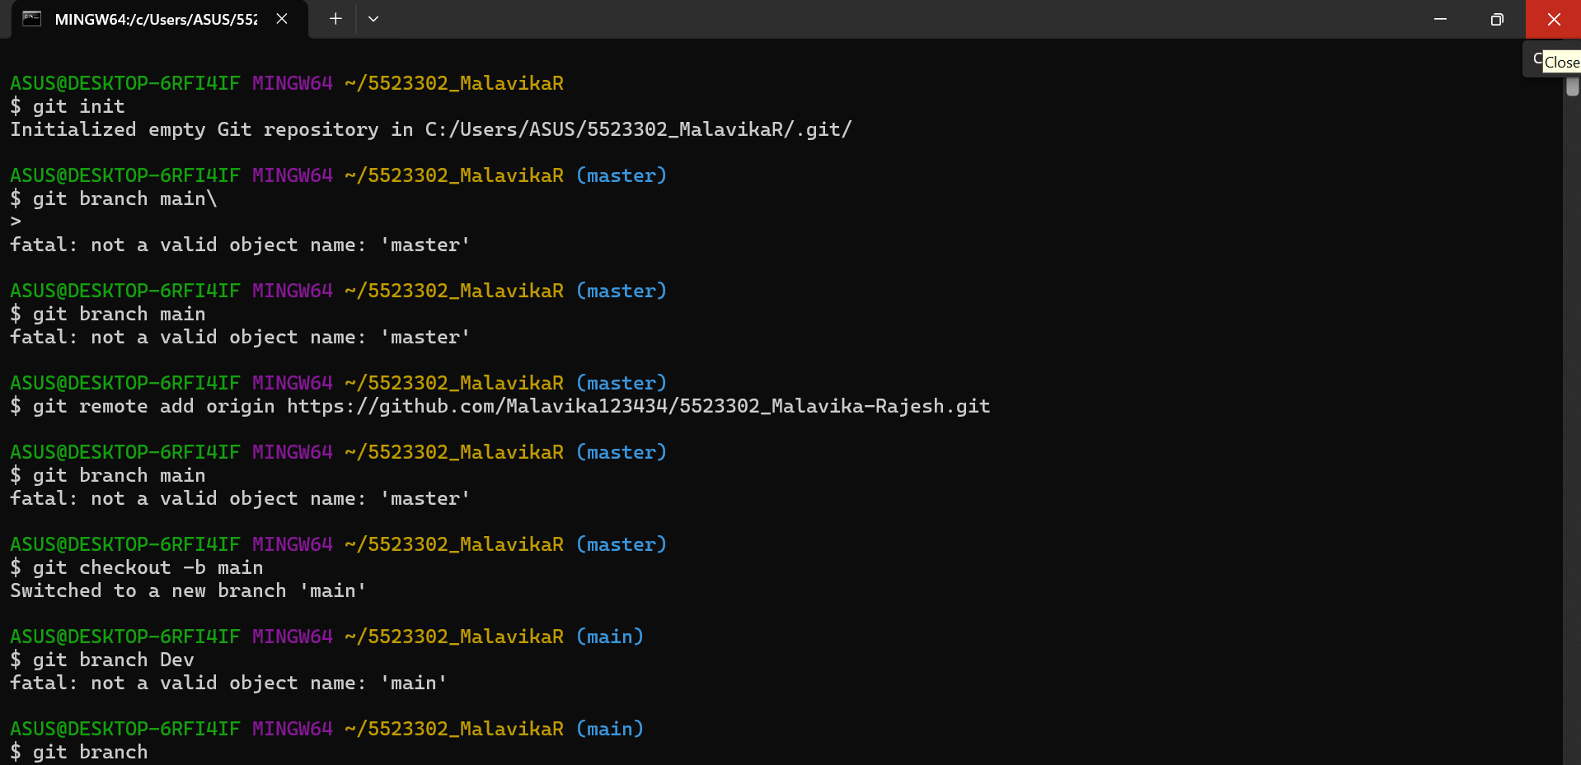

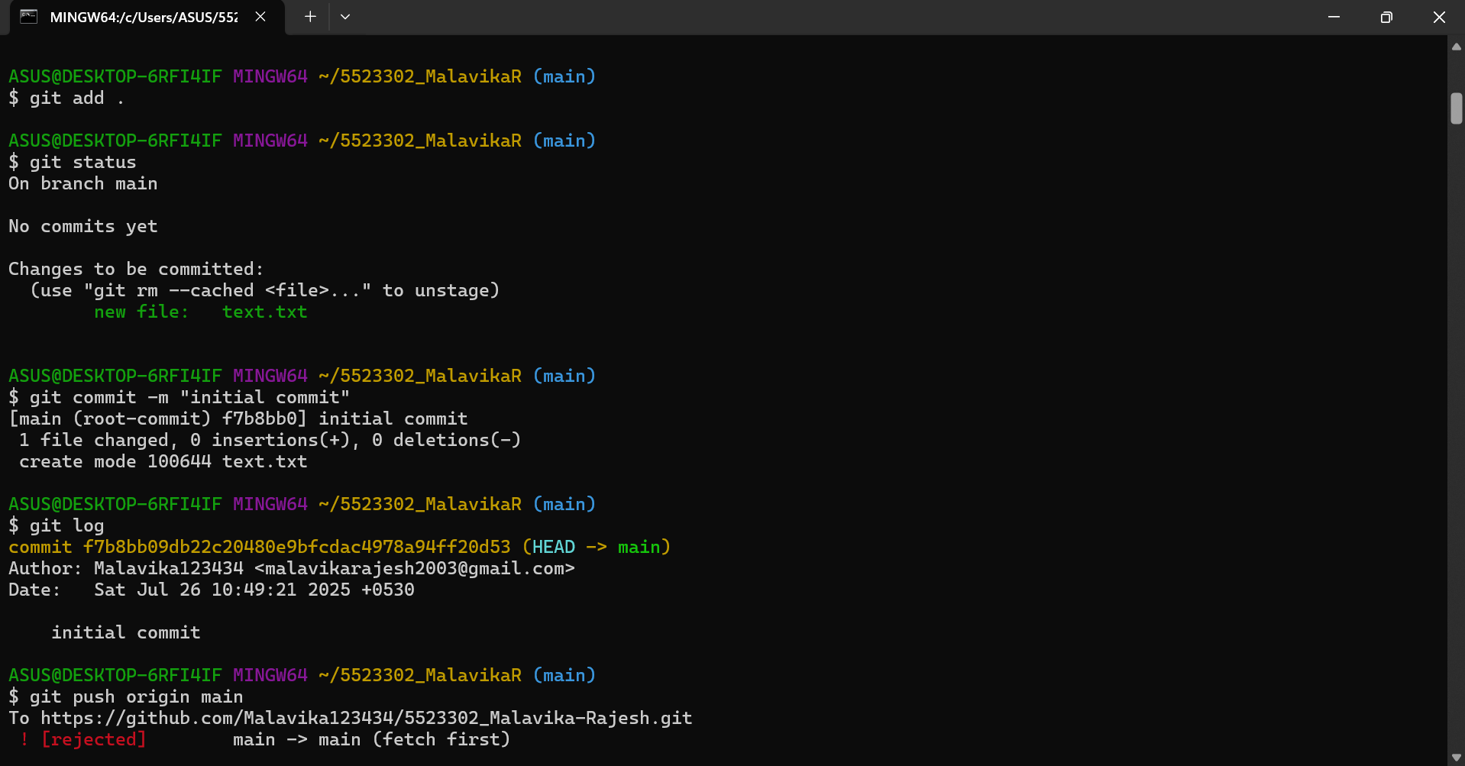 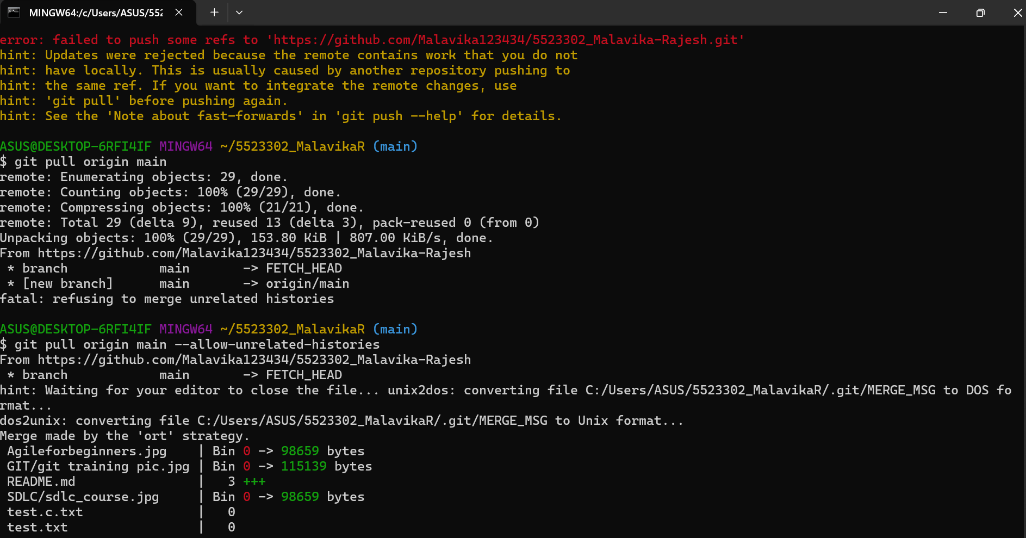 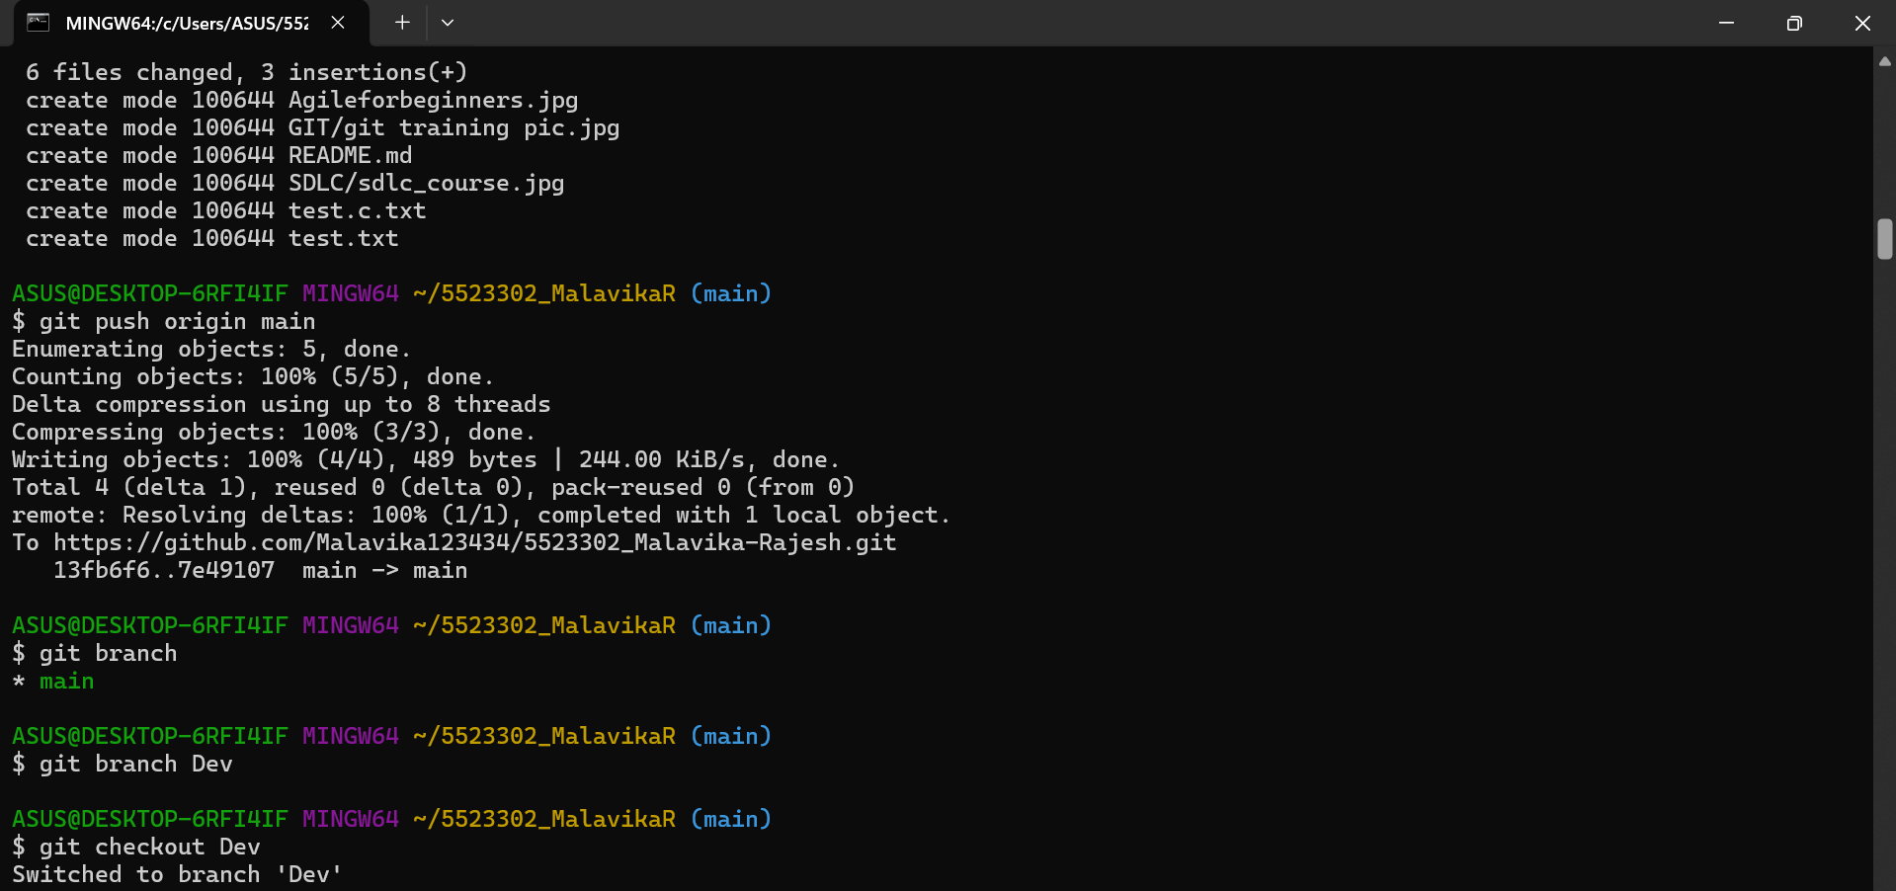 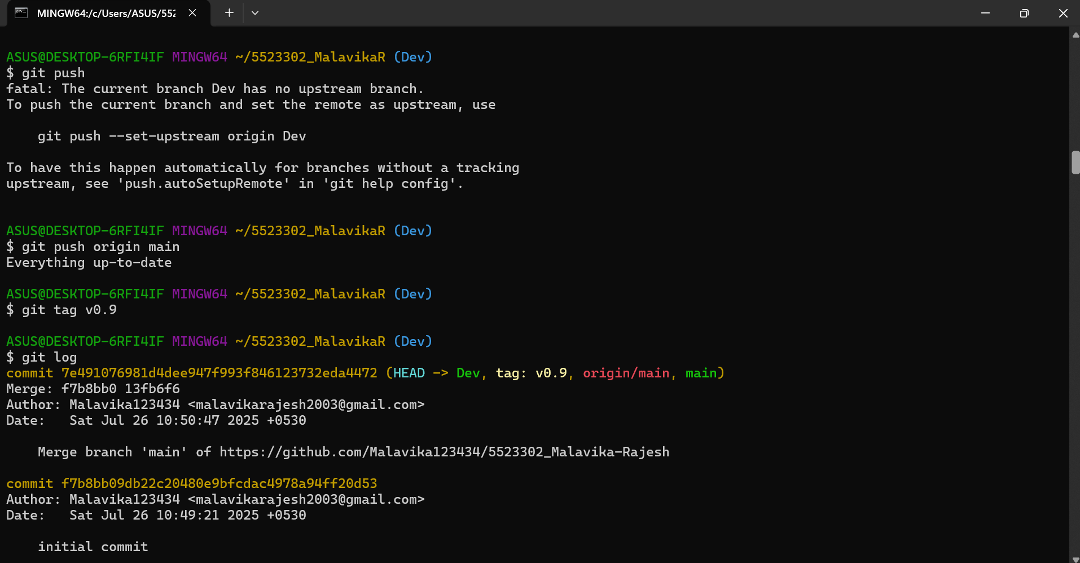 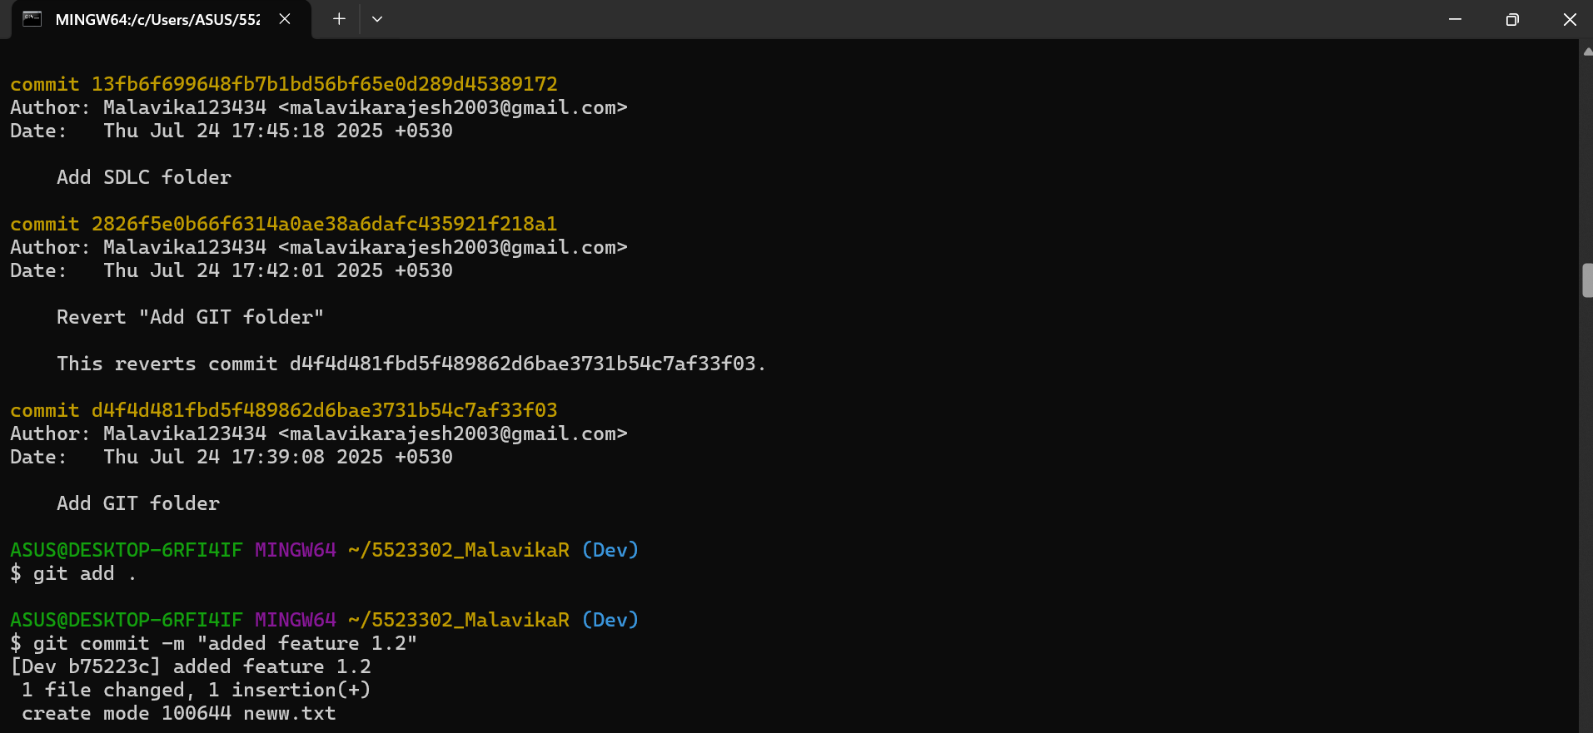 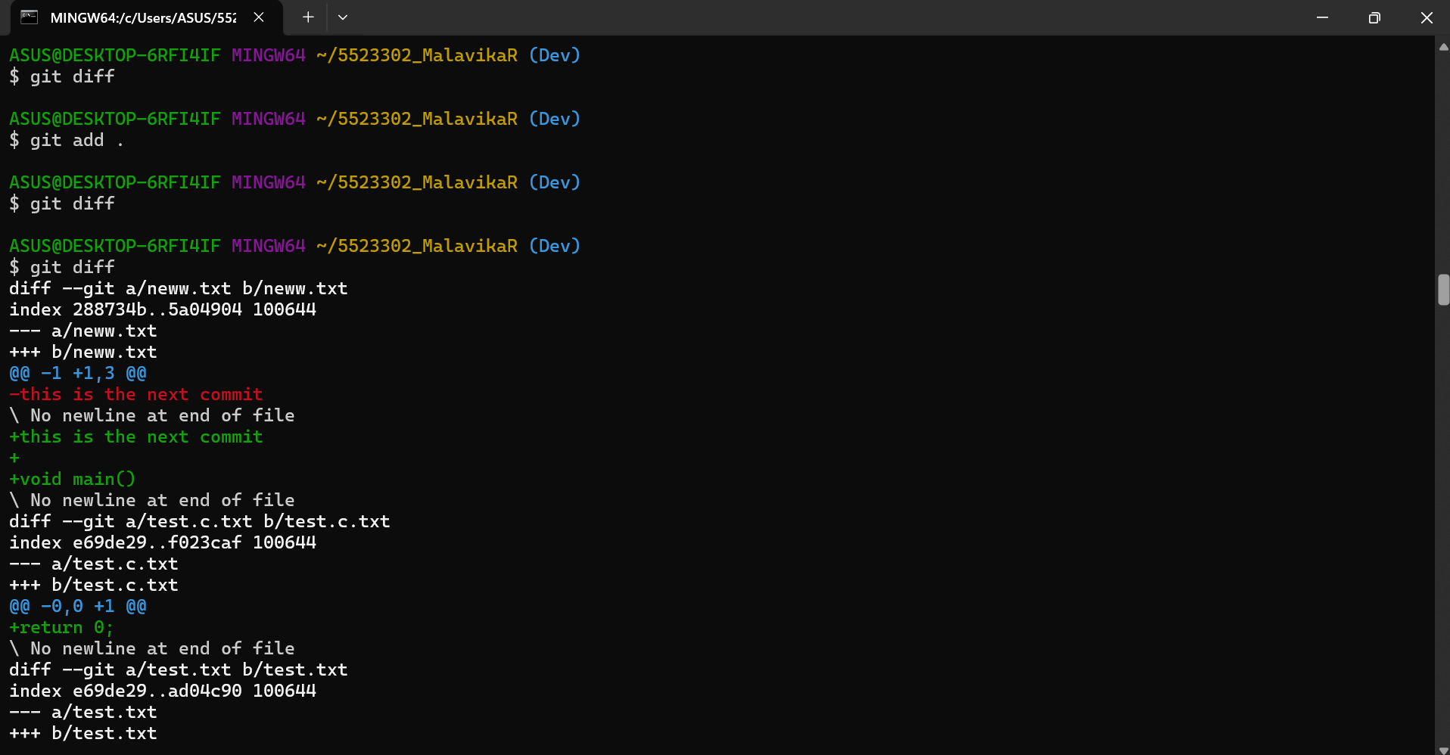 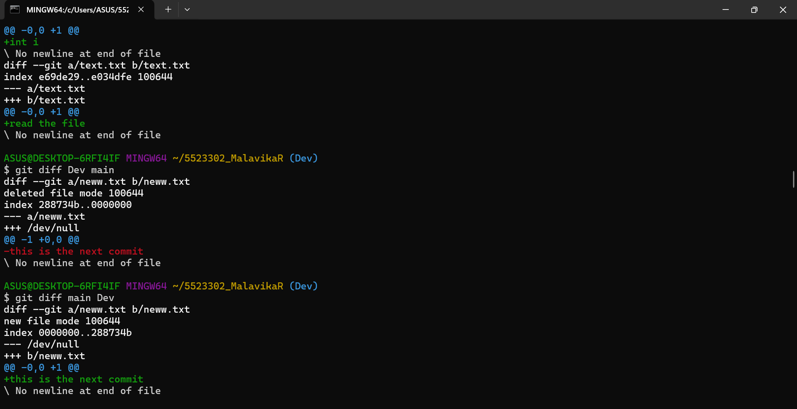 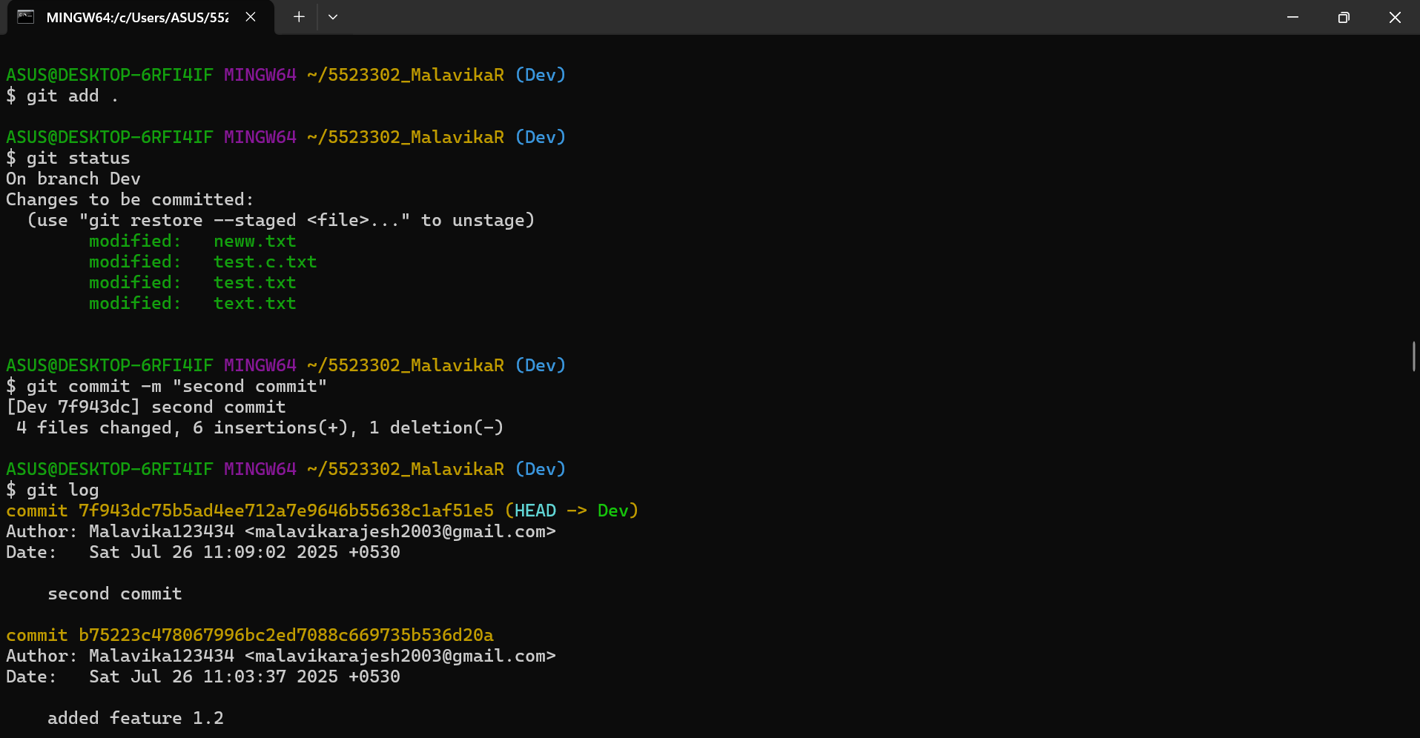 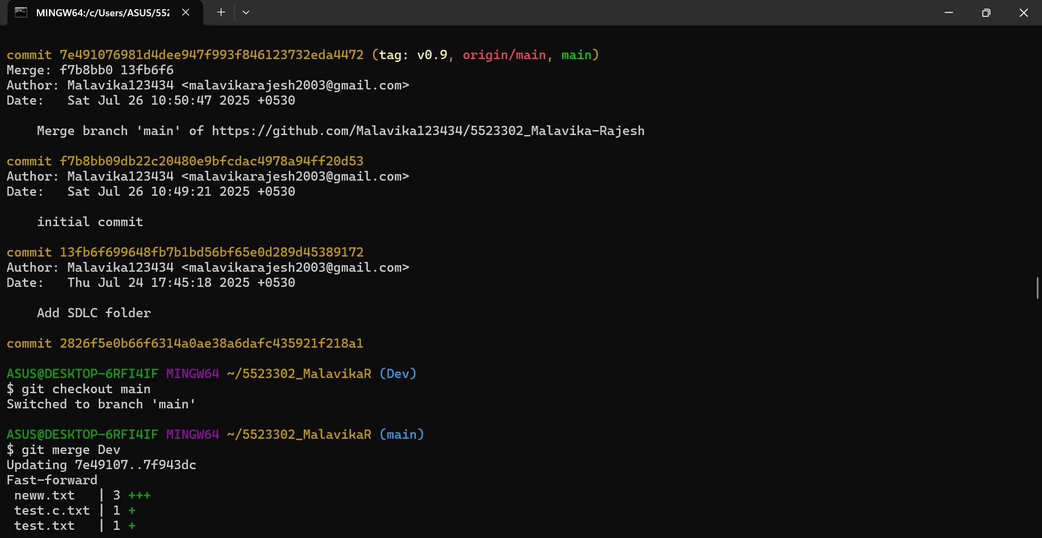 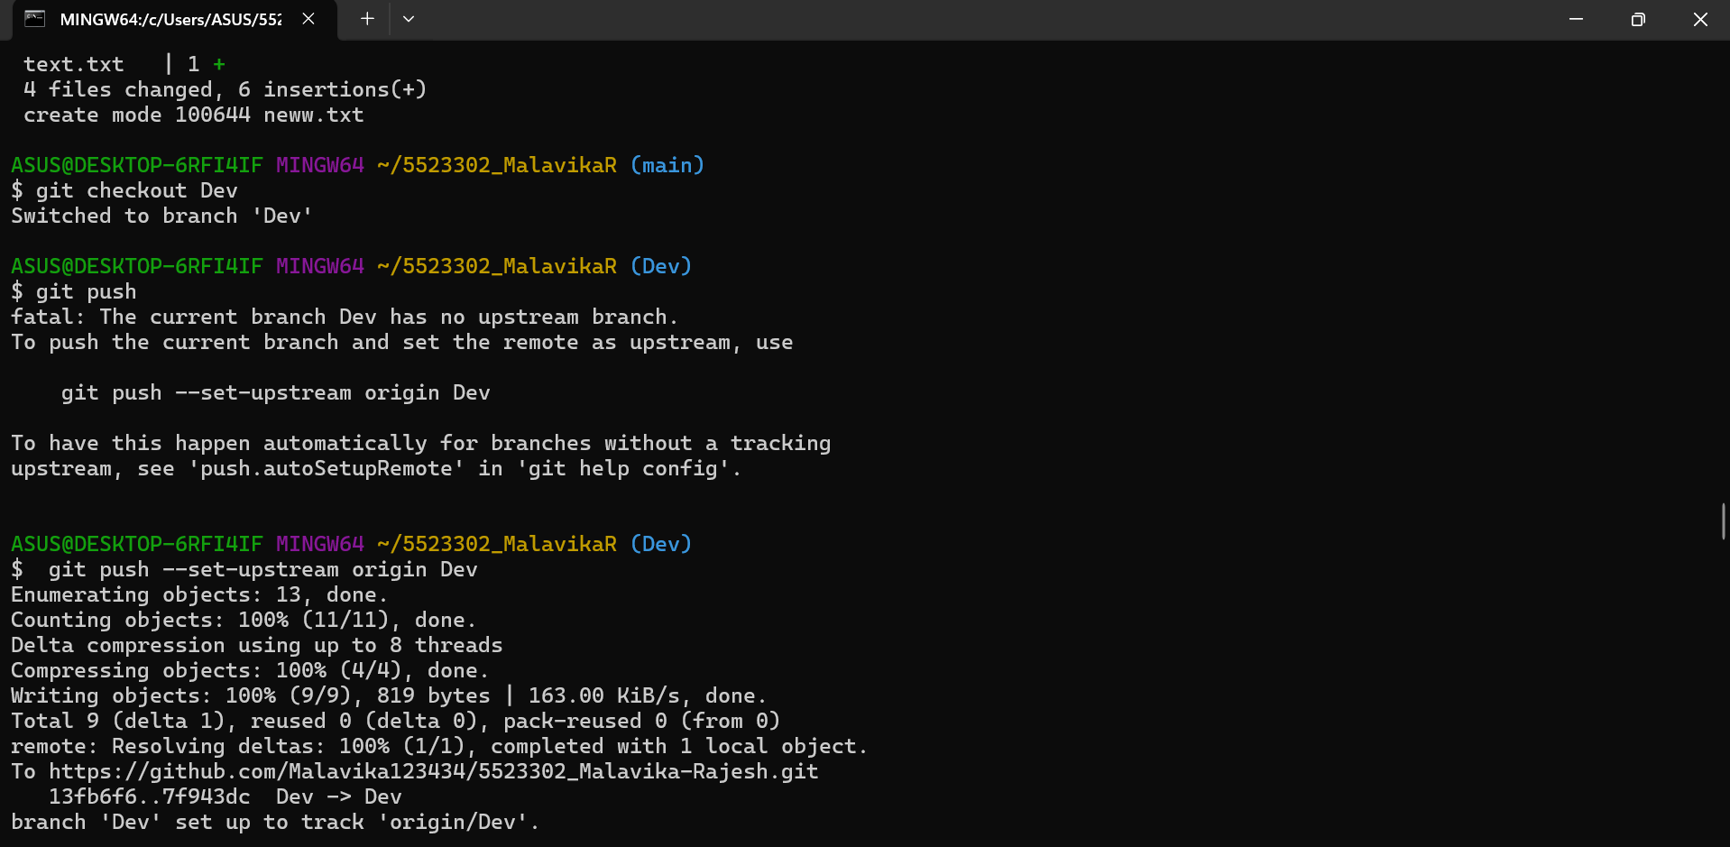 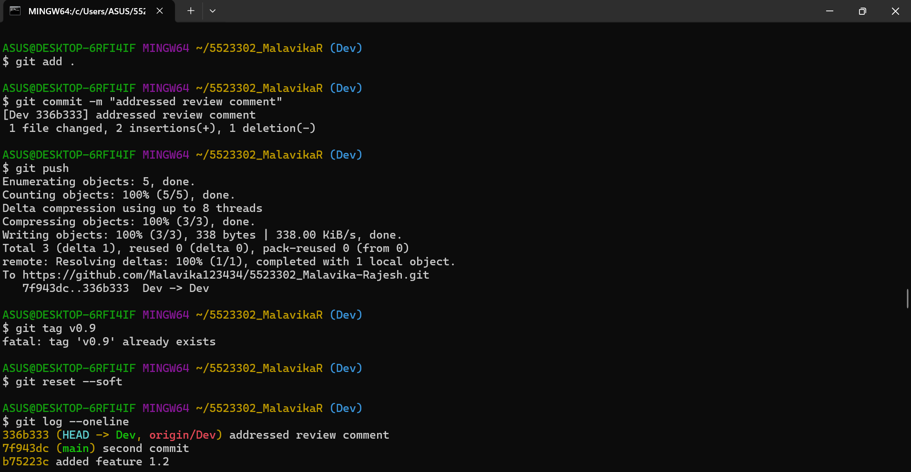 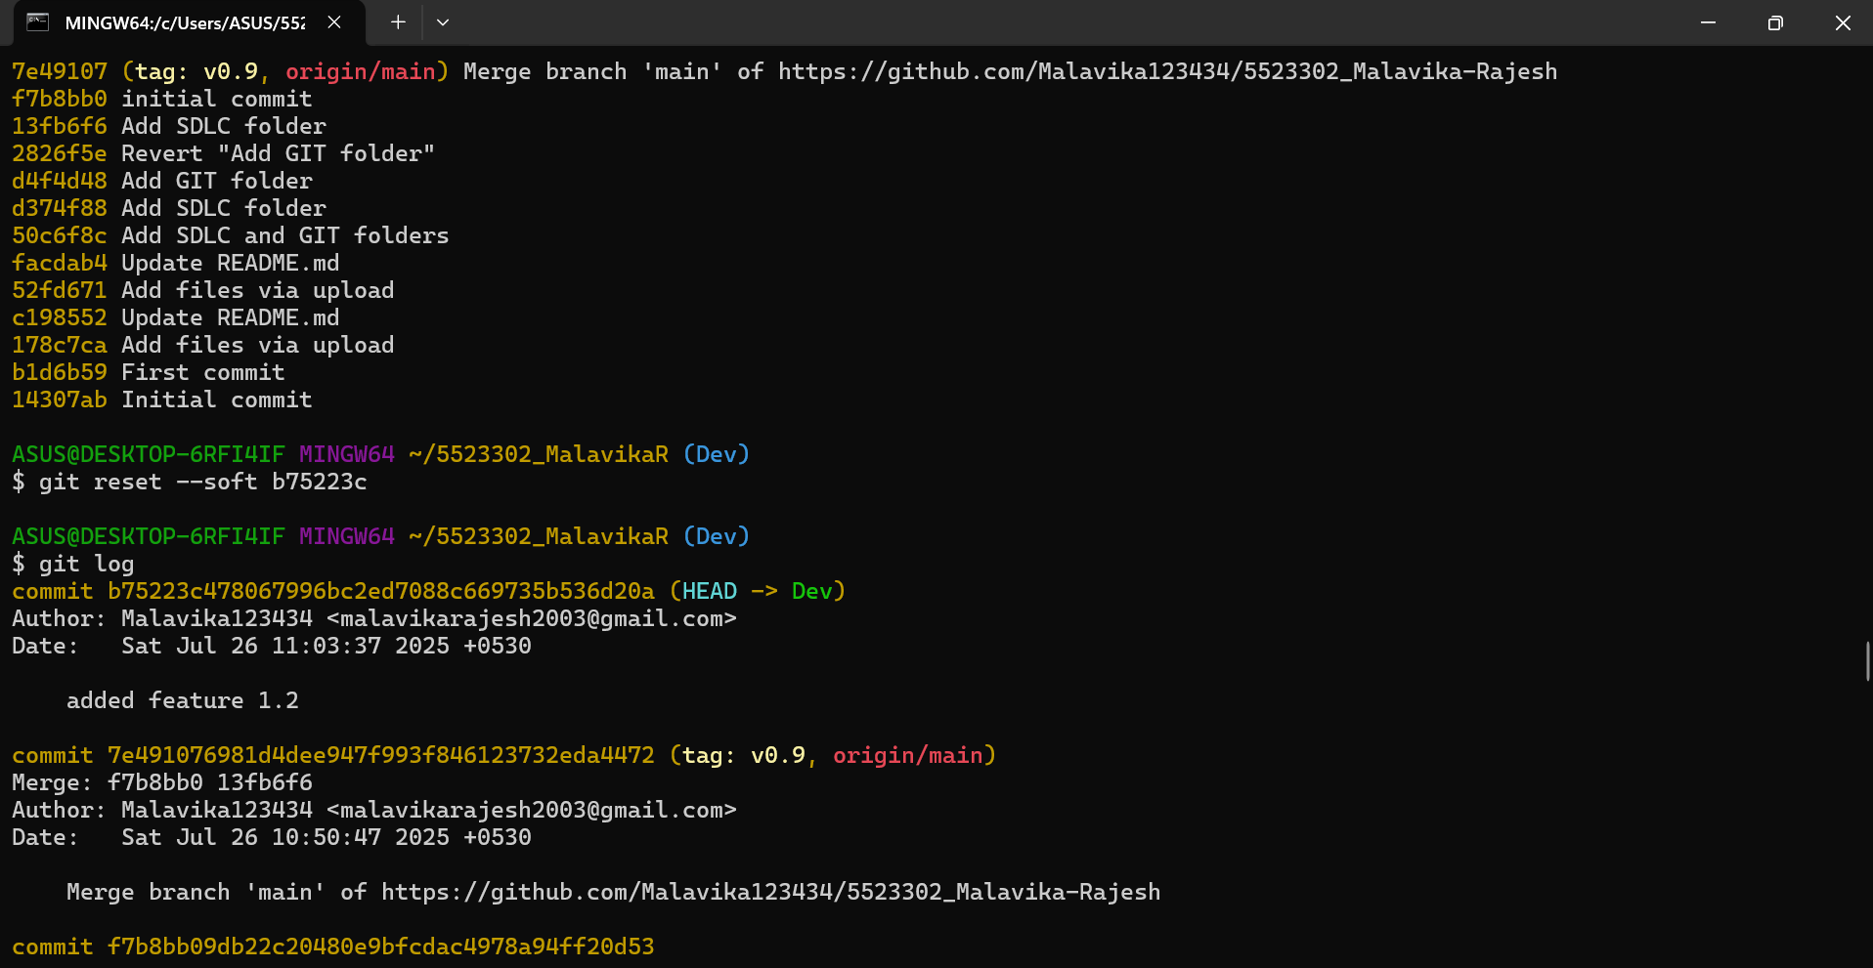 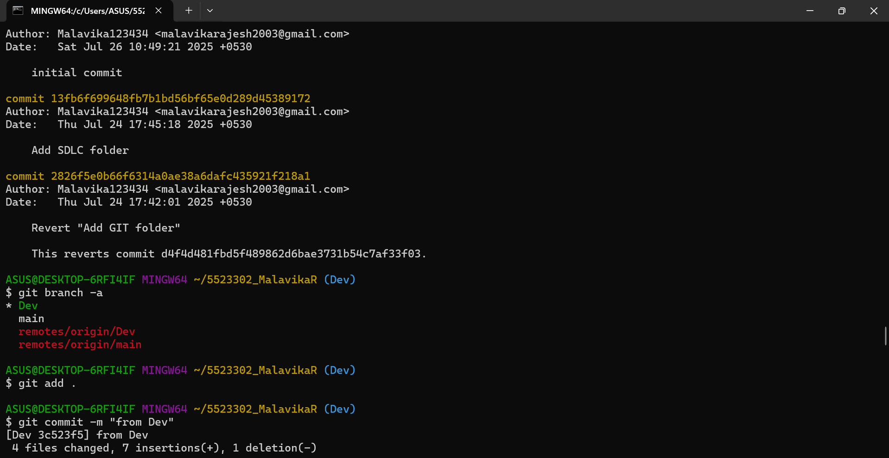 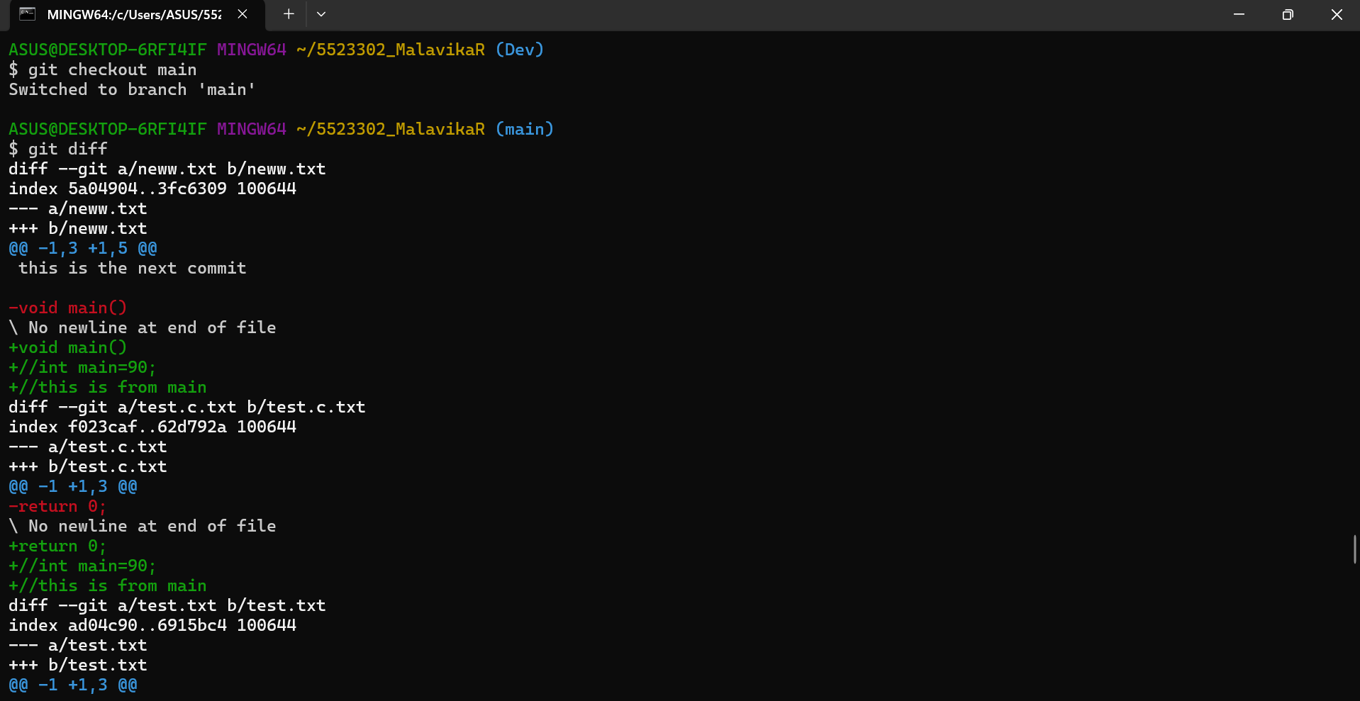 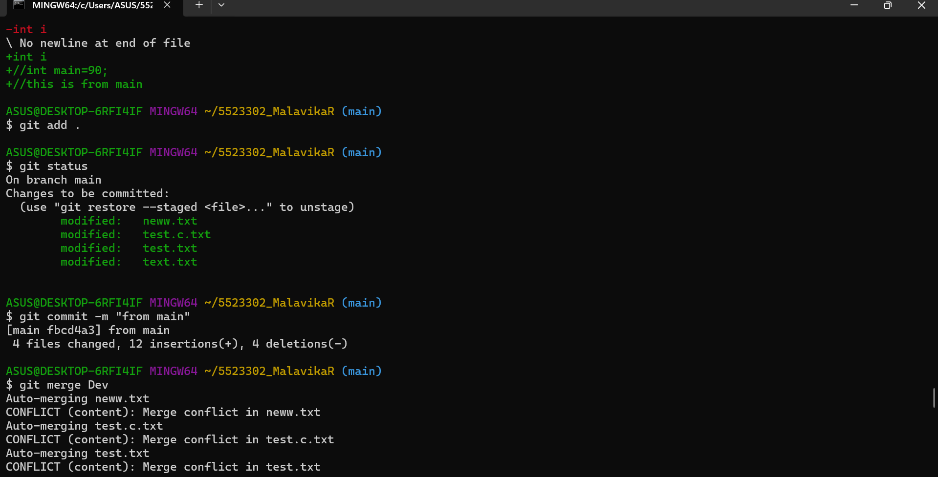 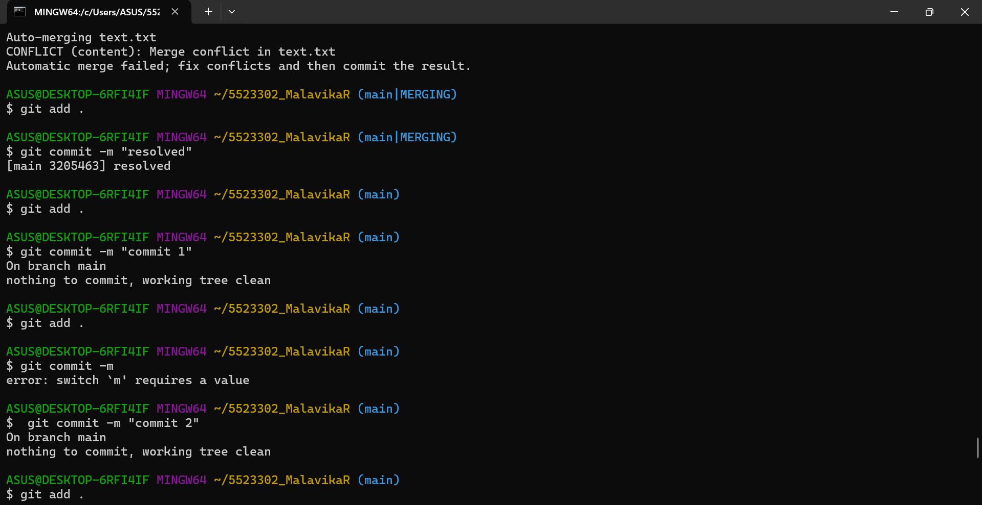 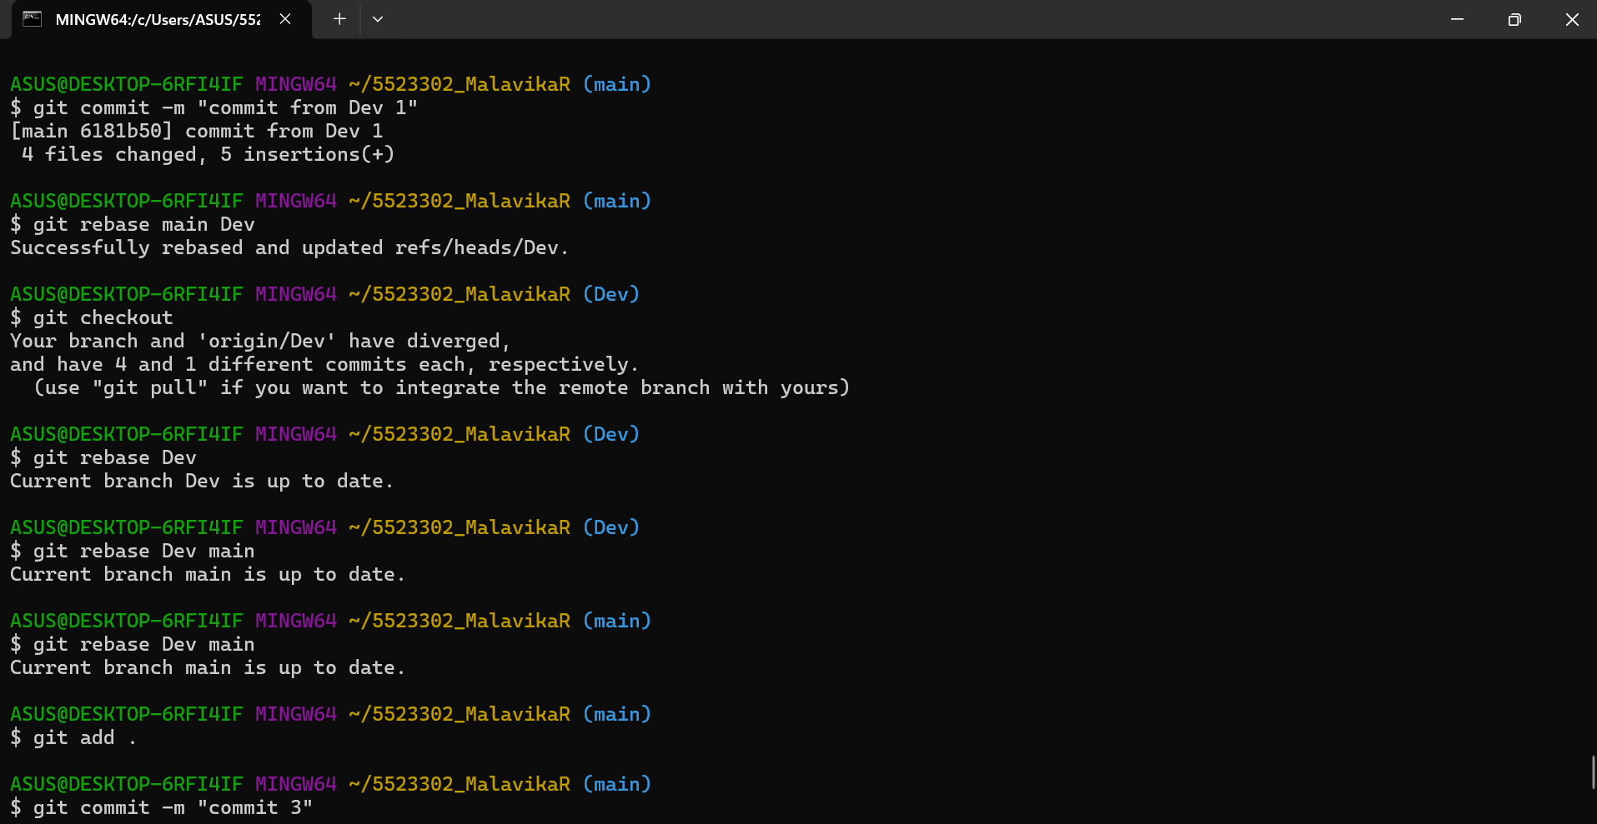 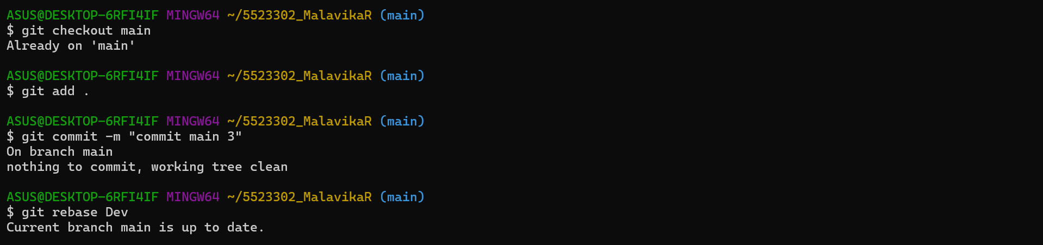

Text version:

ASUS@DESKTOP-6RFI4IF MINGW64 ~/5523302_MalavikaR

$ git init

Initialized empty Git repository in C:/Users/ASUS/5523302_MalavikaR/.git/

ASUS@DESKTOP-6RFI4IF MINGW64 ~/5523302_MalavikaR (master)

$ git branch main\

>

fatal: not a valid object name: 'master'

ASUS@DESKTOP-6RFI4IF MINGW64 ~/5523302_MalavikaR (master)

$ git branch main

fatal: not a valid object name: 'master'

ASUS@DESKTOP-6RFI4IF MINGW64 ~/5523302_MalavikaR (master)

$ git remote add origin https://github.com/Malavika123434/5523302_Malavika-Rajesh.git

ASUS@DESKTOP-6RFI4IF MINGW64 ~/5523302_MalavikaR (master)

$ git branch main

fatal: not a valid object name: 'master'

ASUS@DESKTOP-6RFI4IF MINGW64 ~/5523302_MalavikaR (master)

$ git checkout -b main

Switched to a new branch 'main'

ASUS@DESKTOP-6RFI4IF MINGW64 ~/5523302_MalavikaR (main)

$ git branch Dev

fatal: not a valid object name: 'main'

ASUS@DESKTOP-6RFI4IF MINGW64 ~/5523302_MalavikaR (main)

$ git branch

ASUS@DESKTOP-6RFI4IF MINGW64 ~/5523302_MalavikaR (main)

$ git add .

ASUS@DESKTOP-6RFI4IF MINGW64 ~/5523302_MalavikaR (main)

$ git status

On branch main

No commits yet

Changes to be committed:

(use "git rm --cached <file>..." to unstage)

new file: text.txt

ASUS@DESKTOP-6RFI4IF MINGW64 ~/5523302_MalavikaR (main)

$ git commit -m "initial commit"

[main (root-commit) f7b8bb0] initial commit

1 file changed, 0 insertions(+), 0 deletions(-)

create mode 100644 text.txt

ASUS@DESKTOP-6RFI4IF MINGW64 ~/5523302_MalavikaR (main)

$ git log

commit f7b8bb09db22c20480e9bfcdac4978a94ff20d53 (HEAD -> main)

Author: Malavika123434 <malavikarajesh2003@gmail.com>

Date: Sat Jul 26 10:49:21 2025 +0530

initial commit

ASUS@DESKTOP-6RFI4IF MINGW64 ~/5523302_MalavikaR (main)

$ git push origin main

To https://github.com/Malavika123434/5523302_Malavika-Rajesh.git

! [rejected] main -> main (fetch first)

error: failed to push some refs to 'https://github.com/Malavika123434/5523302_Malavika-Rajesh.git'

hint: Updates were rejected because the remote contains work that you do not

hint: have locally. This is usually caused by another repository pushing to

hint: the same ref. If you want to integrate the remote changes, use

hint: 'git pull' before pushing again.

hint: See the 'Note about fast-forwards' in 'git push --help' for details.

ASUS@DESKTOP-6RFI4IF MINGW64 ~/5523302_MalavikaR (main)

$ git pull origin main

remote: Enumerating objects: 29, done.

remote: Counting objects: 100% (29/29), done.

remote: Compressing objects: 100% (21/21), done.

remote: Total 29 (delta 9), reused 13 (delta 3), pack-reused 0 (from 0)

Unpacking objects: 100% (29/29), 153.80 KiB | 807.00 KiB/s, done.

From https://github.com/Malavika123434/5523302_Malavika-Rajesh

* branch main -> FETCH_HEAD

* [new branch] main -> origin/main

fatal: refusing to merge unrelated histories

ASUS@DESKTOP-6RFI4IF MINGW64 ~/5523302_MalavikaR (main)

$ git pull origin main --allow-unrelated-histories

From https://github.com/Malavika123434/5523302_Malavika-Rajesh

* branch main -> FETCH_HEAD

hint: Waiting for your editor to close the file... unix2dos: converting file C:/Users/ASUS/5523302_MalavikaR/.git/MERGE_MSG to DOS format...

dos2unix: converting file C:/Users/ASUS/5523302_MalavikaR/.git/MERGE_MSG to Unix format...

Merge made by the 'ort' strategy.

Agileforbeginners.jpg | Bin 0 -> 98659 bytes

GIT/git training pic.jpg | Bin 0 -> 115139 bytes

README.md | 3 +++

SDLC/sdlc_course.jpg | Bin 0 -> 98659 bytes

test.c.txt | 0

test.txt | 0

6 files changed, 3 insertions(+)

create mode 100644 Agileforbeginners.jpg

create mode 100644 GIT/git training pic.jpg

create mode 100644 README.md

create mode 100644 SDLC/sdlc_course.jpg

create mode 100644 test.c.txt

create mode 100644 test.txt

ASUS@DESKTOP-6RFI4IF MINGW64 ~/5523302_MalavikaR (main)

$ git push origin main

Enumerating objects: 5, done.

Counting objects: 100% (5/5), done.

Delta compression using up to 8 threads

Compressing objects: 100% (3/3), done.

Writing objects: 100% (4/4), 489 bytes | 244.00 KiB/s, done.

Total 4 (delta 1), reused 0 (delta 0), pack-reused 0 (from 0)

remote: Resolving deltas: 100% (1/1), completed with 1 local object.

To https://github.com/Malavika123434/5523302_Malavika-Rajesh.git

13fb6f6..7e49107 main -> main

ASUS@DESKTOP-6RFI4IF MINGW64 ~/5523302_MalavikaR (main)

$ git branch

* main

ASUS@DESKTOP-6RFI4IF MINGW64 ~/5523302_MalavikaR (main)

$ git branch Dev

ASUS@DESKTOP-6RFI4IF MINGW64 ~/5523302_MalavikaR (main)

$ git checkout Dev

Switched to branch 'Dev'

ASUS@DESKTOP-6RFI4IF MINGW64 ~/5523302_MalavikaR (Dev)

$ git push

fatal: The current branch Dev has no upstream branch.

To push the current branch and set the remote as upstream, use

git push --set-upstream origin Dev

To have this happen automatically for branches without a tracking

upstream, see 'push.autoSetupRemote' in 'git help config'.

ASUS@DESKTOP-6RFI4IF MINGW64 ~/5523302_MalavikaR (Dev)

$ git push origin main

Everything up-to-date

ASUS@DESKTOP-6RFI4IF MINGW64 ~/5523302_MalavikaR (Dev)

$ git tag v0.9

ASUS@DESKTOP-6RFI4IF MINGW64 ~/5523302_MalavikaR (Dev)

$ git log

commit 7e491076981d4dee947f993f846123732eda4472 (HEAD -> Dev, tag: v0.9, origin/main, main)

Merge: f7b8bb0 13fb6f6

Author: Malavika123434 <malavikarajesh2003@gmail.com>

Date: Sat Jul 26 10:50:47 2025 +0530

Merge branch 'main' of https://github.com/Malavika123434/5523302_Malavika-Rajesh

commit f7b8bb09db22c20480e9bfcdac4978a94ff20d53

Author: Malavika123434 <malavikarajesh2003@gmail.com>

Date: Sat Jul 26 10:49:21 2025 +0530

initial commit

commit 13fb6f699648fb7b1bd56bf65e0d289d45389172

Author: Malavika123434 <malavikarajesh2003@gmail.com>

Date: Thu Jul 24 17:45:18 2025 +0530

Add SDLC folder

commit 2826f5e0b66f6314a0ae38a6dafc435921f218a1

Author: Malavika123434 <malavikarajesh2003@gmail.com>

Date: Thu Jul 24 17:42:01 2025 +0530

Revert "Add GIT folder"

This reverts commit d4f4d481fbd5f489862d6bae3731b54c7af33f03.

commit d4f4d481fbd5f489862d6bae3731b54c7af33f03

Author: Malavika123434 <malavikarajesh2003@gmail.com>

Date: Thu Jul 24 17:39:08 2025 +0530

Add GIT folder

ASUS@DESKTOP-6RFI4IF MINGW64 ~/5523302_MalavikaR (Dev)

$ git add .

ASUS@DESKTOP-6RFI4IF MINGW64 ~/5523302_MalavikaR (Dev)

$ git commit -m "added feature 1.2"

[Dev b75223c] added feature 1.2

1 file changed, 1 insertion(+)

create mode 100644 neww.txt

ASUS@DESKTOP-6RFI4IF MINGW64 ~/5523302_MalavikaR (Dev)

$ git diff

ASUS@DESKTOP-6RFI4IF MINGW64 ~/5523302_MalavikaR (Dev)

$ git add .

ASUS@DESKTOP-6RFI4IF MINGW64 ~/5523302_MalavikaR (Dev)

$ git diff

ASUS@DESKTOP-6RFI4IF MINGW64 ~/5523302_MalavikaR (Dev)

$ git diff

diff --git a/neww.txt b/neww.txt

index 288734b..5a04904 100644

--- a/neww.txt

+++ b/neww.txt

@@ -1 +1,3 @@

-this is the next commit

\ No newline at end of file

+this is the next commit

+

+void main()

\ No newline at end of file

diff --git a/test.c.txt b/test.c.txt

index e69de29..f023caf 100644

--- a/test.c.txt

+++ b/test.c.txt

@@ -0,0 +1 @@

+return 0;

\ No newline at end of file

diff --git a/test.txt b/test.txt

index e69de29..ad04c90 100644

--- a/test.txt

+++ b/test.txt

@@ -0,0 +1 @@

+int i

\ No newline at end of file

diff --git a/text.txt b/text.txt

index e69de29..e034dfe 100644

--- a/text.txt

+++ b/text.txt

@@ -0,0 +1 @@

+read the file

\ No newline at end of file

ASUS@DESKTOP-6RFI4IF MINGW64 ~/5523302_MalavikaR (Dev)

$ git diff Dev main

diff --git a/neww.txt b/neww.txt

deleted file mode 100644

index 288734b..0000000

--- a/neww.txt

+++ /dev/null

@@ -1 +0,0 @@

-this is the next commit

\ No newline at end of file

ASUS@DESKTOP-6RFI4IF MINGW64 ~/5523302_MalavikaR (Dev)

$ git diff main Dev

diff --git a/neww.txt b/neww.txt

new file mode 100644

index 0000000..288734b

--- /dev/null

+++ b/neww.txt

@@ -0,0 +1 @@

+this is the next commit

\ No newline at end of file

ASUS@DESKTOP-6RFI4IF MINGW64 ~/5523302_MalavikaR (Dev)

$ git add .

ASUS@DESKTOP-6RFI4IF MINGW64 ~/5523302_MalavikaR (Dev)

$ git status

On branch Dev

Changes to be committed:

(use "git restore --staged <file>..." to unstage)

modified: neww.txt

modified: test.c.txt

modified: test.txt

modified: text.txt

ASUS@DESKTOP-6RFI4IF MINGW64 ~/5523302_MalavikaR (Dev)

$ git commit -m "second commit"

[Dev 7f943dc] second commit

4 files changed, 6 insertions(+), 1 deletion(-)

ASUS@DESKTOP-6RFI4IF MINGW64 ~/5523302_MalavikaR (Dev)

$ git log

commit 7f943dc75b5ad4ee712a7e9646b55638c1af51e5 (HEAD -> Dev)

Author: Malavika123434 <malavikarajesh2003@gmail.com>

Date: Sat Jul 26 11:09:02 2025 +0530

second commit

commit b75223c478067996bc2ed7088c669735b536d20a

Author: Malavika123434 <malavikarajesh2003@gmail.com>

Date: Sat Jul 26 11:03:37 2025 +0530

added feature 1.2

commit 7e491076981d4dee947f993f846123732eda4472 (tag: v0.9, origin/main, main)

Merge: f7b8bb0 13fb6f6

Author: Malavika123434 <malavikarajesh2003@gmail.com>

Date: Sat Jul 26 10:50:47 2025 +0530

Merge branch 'main' of https://github.com/Malavika123434/5523302_Malavika-Rajesh

commit f7b8bb09db22c20480e9bfcdac4978a94ff20d53

Author: Malavika123434 <malavikarajesh2003@gmail.com>

Date: Sat Jul 26 10:49:21 2025 +0530

initial commit

commit 13fb6f699648fb7b1bd56bf65e0d289d45389172

Author: Malavika123434 <malavikarajesh2003@gmail.com>

Date: Thu Jul 24 17:45:18 2025 +0530

Add SDLC folder

commit 2826f5e0b66f6314a0ae38a6dafc435921f218a1

ASUS@DESKTOP-6RFI4IF MINGW64 ~/5523302_MalavikaR (Dev)

$ git checkout main

Switched to branch 'main'

ASUS@DESKTOP-6RFI4IF MINGW64 ~/5523302_MalavikaR (main)

$ git merge Dev

Updating 7e49107..7f943dc

Fast-forward

neww.txt | 3 +++

test.c.txt | 1 +

test.txt | 1 +

text.txt | 1 +

4 files changed, 6 insertions(+)

create mode 100644 neww.txt

ASUS@DESKTOP-6RFI4IF MINGW64 ~/5523302_MalavikaR (main)

$ git checkout Dev

Switched to branch 'Dev'

ASUS@DESKTOP-6RFI4IF MINGW64 ~/5523302_MalavikaR (Dev)

$ git push

fatal: The current branch Dev has no upstream branch.

To push the current branch and set the remote as upstream, use

git push --set-upstream origin Dev

To have this happen automatically for branches without a tracking

upstream, see 'push.autoSetupRemote' in 'git help config'.

ASUS@DESKTOP-6RFI4IF MINGW64 ~/5523302_MalavikaR (Dev)

$ git push --set-upstream origin Dev

Enumerating objects: 13, done.

Counting objects: 100% (11/11), done.

Delta compression using up to 8 threads

Compressing objects: 100% (4/4), done.

Writing objects: 100% (9/9), 819 bytes | 163.00 KiB/s, done.

Total 9 (delta 1), reused 0 (delta 0), pack-reused 0 (from 0)

remote: Resolving deltas: 100% (1/1), completed with 1 local object.

To https://github.com/Malavika123434/5523302_Malavika-Rajesh.git

13fb6f6..7f943dc Dev -> Dev

branch 'Dev' set up to track 'origin/Dev'.

ASUS@DESKTOP-6RFI4IF MINGW64 ~/5523302_MalavikaR (Dev)

$ git add .

ASUS@DESKTOP-6RFI4IF MINGW64 ~/5523302_MalavikaR (Dev)

$ git commit -m "addressed review comment"

[Dev 336b333] addressed review comment

1 file changed, 2 insertions(+), 1 deletion(-)

ASUS@DESKTOP-6RFI4IF MINGW64 ~/5523302_MalavikaR (Dev)

$ git push

Enumerating objects: 5, done.

Counting objects: 100% (5/5), done.

Delta compression using up to 8 threads

Compressing objects: 100% (3/3), done.

Writing objects: 100% (3/3), 338 bytes | 338.00 KiB/s, done.

Total 3 (delta 1), reused 0 (delta 0), pack-reused 0 (from 0)

remote: Resolving deltas: 100% (1/1), completed with 1 local object.

To https://github.com/Malavika123434/5523302_Malavika-Rajesh.git

7f943dc..336b333 Dev -> Dev

ASUS@DESKTOP-6RFI4IF MINGW64 ~/5523302_MalavikaR (Dev)

$ git tag v0.9

fatal: tag 'v0.9' already exists

ASUS@DESKTOP-6RFI4IF MINGW64 ~/5523302_MalavikaR (Dev)

$ git reset --soft

ASUS@DESKTOP-6RFI4IF MINGW64 ~/5523302_MalavikaR (Dev)

$ git log --oneline

336b333 (HEAD -> Dev, origin/Dev) addressed review comment

7f943dc (main) second commit

b75223c added feature 1.2

7e49107 (tag: v0.9, origin/main) Merge branch 'main' of https://github.com/Malavika123434/5523302_Malavika-Rajesh

f7b8bb0 initial commit

13fb6f6 Add SDLC folder

2826f5e Revert "Add GIT folder"

d4f4d48 Add GIT folder

d374f88 Add SDLC folder

50c6f8c Add SDLC and GIT folders

facdab4 Update README.md

52fd671 Add files via upload

c198552 Update README.md

178c7ca Add files via upload

b1d6b59 First commit

14307ab Initial commit

ASUS@DESKTOP-6RFI4IF MINGW64 ~/5523302_MalavikaR (Dev)

$ git reset --soft b75223c

ASUS@DESKTOP-6RFI4IF MINGW64 ~/5523302_MalavikaR (Dev)

$ git log

commit b75223c478067996bc2ed7088c669735b536d20a (HEAD -> Dev)

Author: Malavika123434 <malavikarajesh2003@gmail.com>

Date: Sat Jul 26 11:03:37 2025 +0530

added feature 1.2

commit 7e491076981d4dee947f993f846123732eda4472 (tag: v0.9, origin/main)

Merge: f7b8bb0 13fb6f6

Author: Malavika123434 <malavikarajesh2003@gmail.com>

Date: Sat Jul 26 10:50:47 2025 +0530

Merge branch 'main' of https://github.com/Malavika123434/5523302_Malavika-Rajesh

commit f7b8bb09db22c20480e9bfcdac4978a94ff20d53

Author: Malavika123434 <malavikarajesh2003@gmail.com>

Date: Sat Jul 26 10:49:21 2025 +0530

initial commit

commit 13fb6f699648fb7b1bd56bf65e0d289d45389172

Author: Malavika123434 <malavikarajesh2003@gmail.com>

Date: Thu Jul 24 17:45:18 2025 +0530

Add SDLC folder

commit 2826f5e0b66f6314a0ae38a6dafc435921f218a1

Author: Malavika123434 <malavikarajesh2003@gmail.com>

Date: Thu Jul 24 17:42:01 2025 +0530

Revert "Add GIT folder"

This reverts commit d4f4d481fbd5f489862d6bae3731b54c7af33f03.

ASUS@DESKTOP-6RFI4IF MINGW64 ~/5523302_MalavikaR (Dev)

$ git branch -a

* Dev

main

remotes/origin/Dev

remotes/origin/main

ASUS@DESKTOP-6RFI4IF MINGW64 ~/5523302_MalavikaR (Dev)

$ git add .

ASUS@DESKTOP-6RFI4IF MINGW64 ~/5523302_MalavikaR (Dev)

$ git commit -m "from Dev"

[Dev 3c523f5] from Dev

4 files changed, 7 insertions(+), 1 deletion(-)

ASUS@DESKTOP-6RFI4IF MINGW64 ~/5523302_MalavikaR (Dev)

$ git checkout main

Switched to branch 'main'

ASUS@DESKTOP-6RFI4IF MINGW64 ~/5523302_MalavikaR (main)

$ git diff

diff --git a/neww.txt b/neww.txt

index 5a04904..3fc6309 100644

--- a/neww.txt

+++ b/neww.txt

@@ -1,3 +1,5 @@

this is the next commit

-void main()

\ No newline at end of file

+void main()

+//int main=90;

+//this is from main

diff --git a/test.c.txt b/test.c.txt

index f023caf..62d792a 100644

--- a/test.c.txt

+++ b/test.c.txt

@@ -1 +1,3 @@

-return 0;

\ No newline at end of file

+return 0;

+//int main=90;

+//this is from main

diff --git a/test.txt b/test.txt

index ad04c90..6915bc4 100644

--- a/test.txt

+++ b/test.txt

@@ -1 +1,3 @@

-int i

\ No newline at end of file

+int i

+//int main=90;

+//this is from main

ASUS@DESKTOP-6RFI4IF MINGW64 ~/5523302_MalavikaR (main)

$ git add .

ASUS@DESKTOP-6RFI4IF MINGW64 ~/5523302_MalavikaR (main)

$ git status

On branch main

Changes to be committed:

(use "git restore --staged <file>..." to unstage)

modified: neww.txt

modified: test.c.txt

modified: test.txt

modified: text.txt

ASUS@DESKTOP-6RFI4IF MINGW64 ~/5523302_MalavikaR (main)

$ git commit -m "from main"

[main fbcd4a3] from main

4 files changed, 12 insertions(+), 4 deletions(-)

ASUS@DESKTOP-6RFI4IF MINGW64 ~/5523302_MalavikaR (main)

$ git merge Dev

Auto-merging neww.txt

CONFLICT (content): Merge conflict in neww.txt

Auto-merging test.c.txt

CONFLICT (content): Merge conflict in test.c.txt

Auto-merging test.txt

CONFLICT (content): Merge conflict in test.txt

Auto-merging text.txt

CONFLICT (content): Merge conflict in text.txt

Automatic merge failed; fix conflicts and then commit the result.

ASUS@DESKTOP-6RFI4IF MINGW64 ~/5523302_MalavikaR (main|MERGING)

$ git add .

ASUS@DESKTOP-6RFI4IF MINGW64 ~/5523302_MalavikaR (main|MERGING)

$ git commit -m "resolved"

[main 3205463] resolved

ASUS@DESKTOP-6RFI4IF MINGW64 ~/5523302_MalavikaR (main)

$ git add .

ASUS@DESKTOP-6RFI4IF MINGW64 ~/5523302_MalavikaR (main)

$ git commit -m "commit 1"

On branch main

nothing to commit, working tree clean

ASUS@DESKTOP-6RFI4IF MINGW64 ~/5523302_MalavikaR (main)

$ git add .

ASUS@DESKTOP-6RFI4IF MINGW64 ~/5523302_MalavikaR (main)

$ git commit -m

error: switch `m' requires a value

ASUS@DESKTOP-6RFI4IF MINGW64 ~/5523302_MalavikaR (main)

$ git commit -m "commit 2"

On branch main

nothing to commit, working tree clean

ASUS@DESKTOP-6RFI4IF MINGW64 ~/5523302_MalavikaR (main)

$ git add .

ASUS@DESKTOP-6RFI4IF MINGW64 ~/5523302_MalavikaR (main)

$ git commit -m "commit from Dev 1"

[main 6181b50] commit from Dev 1

4 files changed, 5 insertions(+)

ASUS@DESKTOP-6RFI4IF MINGW64 ~/5523302_MalavikaR (main)

$ git rebase main Dev

Successfully rebased and updated refs/heads/Dev.

ASUS@DESKTOP-6RFI4IF MINGW64 ~/5523302_MalavikaR (Dev)

$ git checkout

Your branch and 'origin/Dev' have diverged,

and have 4 and 1 different commits each, respectively.

(use "git pull" if you want to integrate the remote branch with yours)

ASUS@DESKTOP-6RFI4IF MINGW64 ~/5523302_MalavikaR (Dev)

$ git rebase Dev

Current branch Dev is up to date.

ASUS@DESKTOP-6RFI4IF MINGW64 ~/5523302_MalavikaR (Dev)

$ git rebase Dev main

Current branch main is up to date.

ASUS@DESKTOP-6RFI4IF MINGW64 ~/5523302_MalavikaR (main)

$ git rebase Dev main

Current branch main is up to date.

ASUS@DESKTOP-6RFI4IF MINGW64 ~/5523302_MalavikaR (main)

$ git add .

ASUS@DESKTOP-6RFI4IF MINGW64 ~/5523302_MalavikaR (main)

$ git commit -m "commit 3"

On branch main

nothing to commit, working tree clean

ASUS@DESKTOP-6RFI4IF MINGW64 ~/5523302_MalavikaR (main)

$ git checkout main

Already on 'main'

ASUS@DESKTOP-6RFI4IF MINGW64 ~/5523302_MalavikaR (main)

$ git add .

ASUS@DESKTOP-6RFI4IF MINGW64 ~/5523302_MalavikaR (main)

$ git commit -m "commit main 3"

On branch main

nothing to commit, working tree clean

ASUS@DESKTOP-6RFI4IF MINGW64 ~/5523302_MalavikaR (main)

$ git rebase Dev

Current branch main is up to date.

**Git Bash GUI:**

